**KUBERNETES:**

**PREQUISITES:**

1. CREATE VPC
2. ATTACH INTERNET GATEWAY TO THAT VPC
3. CREATE 2 PUBLIC SUBNETS
4. CREATE ROUTE TABLE
5. IN ROUTES ATTACH INTERNET GATEWAY
6. IN SUBNET ASSOCIATION, SELECT PUBLIC SUBNET AND CLICK ON SAVE.

**GO TO IAM IN AWS CONSOLE :**

**CREATE ROLE FOR CLUSTER & NODE GROUP**

1. **ROLE FOR EKS CLUSTER: use case type eks & select eks cluster , save.**

[AmazonEKSClusterPolicy](https://us-east-1.console.aws.amazon.com/iam/home?region=us-east-1#/policies/details/arn%3Aaws%3Aiam%3A%3Aaws%3Apolicy%2FAmazonEKSClusterPolicy)

**ROLE FOR NODE-GROUP: use case, select ec2 & click on next**

1. [AmazonEC2ContainerRegistryReadOnly](https://us-east-1.console.aws.amazon.com/iam/home?region=us-east-1#/policies/details/arn%3Aaws%3Aiam%3A%3Aaws%3Apolicy%2FAmazonEC2ContainerRegistryReadOnly)
2. [AmazonEKS_CNI_Policy](https://us-east-1.console.aws.amazon.com/iam/home?region=us-east-1#/policies/details/arn%3Aaws%3Aiam%3A%3Aaws%3Apolicy%2FAmazonEKS_CNI_Policy)
3. [AmazonEKSWorkerNodePolicy](https://us-east-1.console.aws.amazon.com/iam/home?region=us-east-1#/policies/details/arn%3Aaws%3Aiam%3A%3Aaws%3Apolicy%2FAmazonEKSWorkerNodePolicy)
4. [AmazonEBSCSIDriverPolicy](https://us-east-1.console.aws.amazon.com/iam/home?region=us-east-1#/policies/details/arn%3Aaws%3Aiam%3A%3Aaws%3Apolicy%2Fservice-role%2FAmazonEBSCSIDriverPolicy)
5. [AmazonEFSCSIDriverPolicy](https://us-east-1.console.aws.amazon.com/iam/home?region=us-east-1#/policies/details/arn%3Aaws%3Aiam%3A%3Aaws%3Apolicy%2Fservice-role%2FAmazonEFSCSIDriverPolicy)
6. CREATE KEY PAIR
7. CREATE SECURITY GROUP: ALLOW ALL TRAFFIC
8. **AWS-CLI LINK**: <https://docs.aws.amazon.com/cli/latest/userguide/getting-started-install.html>
9. AFTER DOWNLOADING AWS CI , CONFIGURE IN COMMAND PROMPT USING **aws configure** COMMAND
10. **KUBECTL LINK** :RUN BELOW COMMAND IN COMMAND PROMPT

curl.exe -O <https://s3.us-west-2.amazonaws.com/amazon-eks/1.29.0/2024-01-04/bin/windows/amd64/kubectl.exe>

1. SET PATH IN ENVIRONMENT VARIABLE

**CLUSTER SET UP:**

**KUBECONFIG**

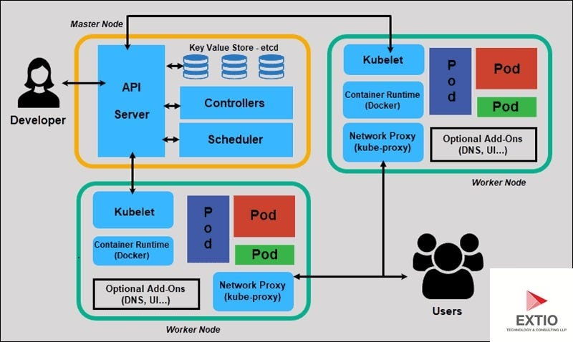

**CREATE ROLE FOR CLUSTER IN IAM**

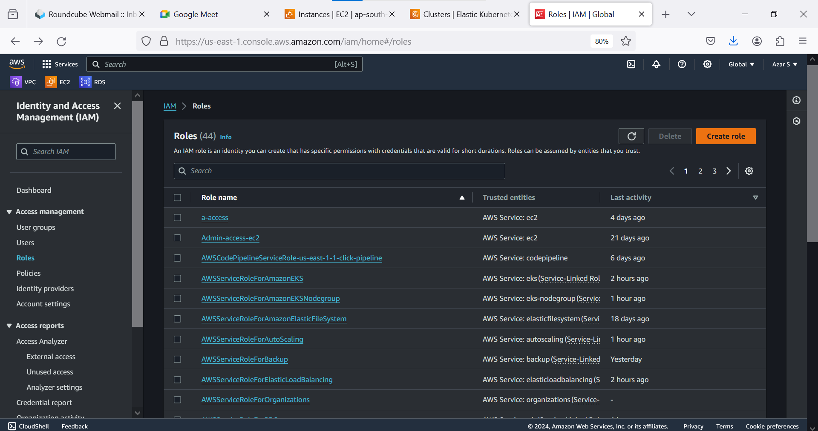 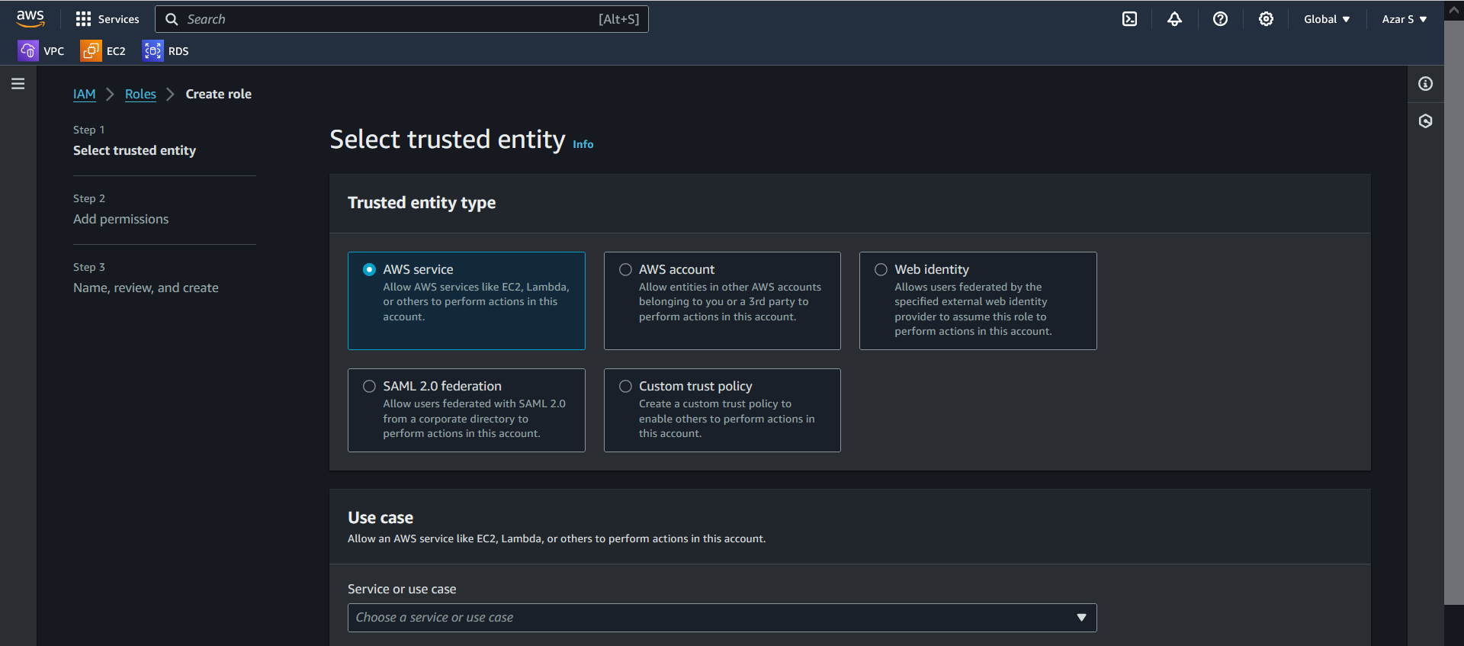 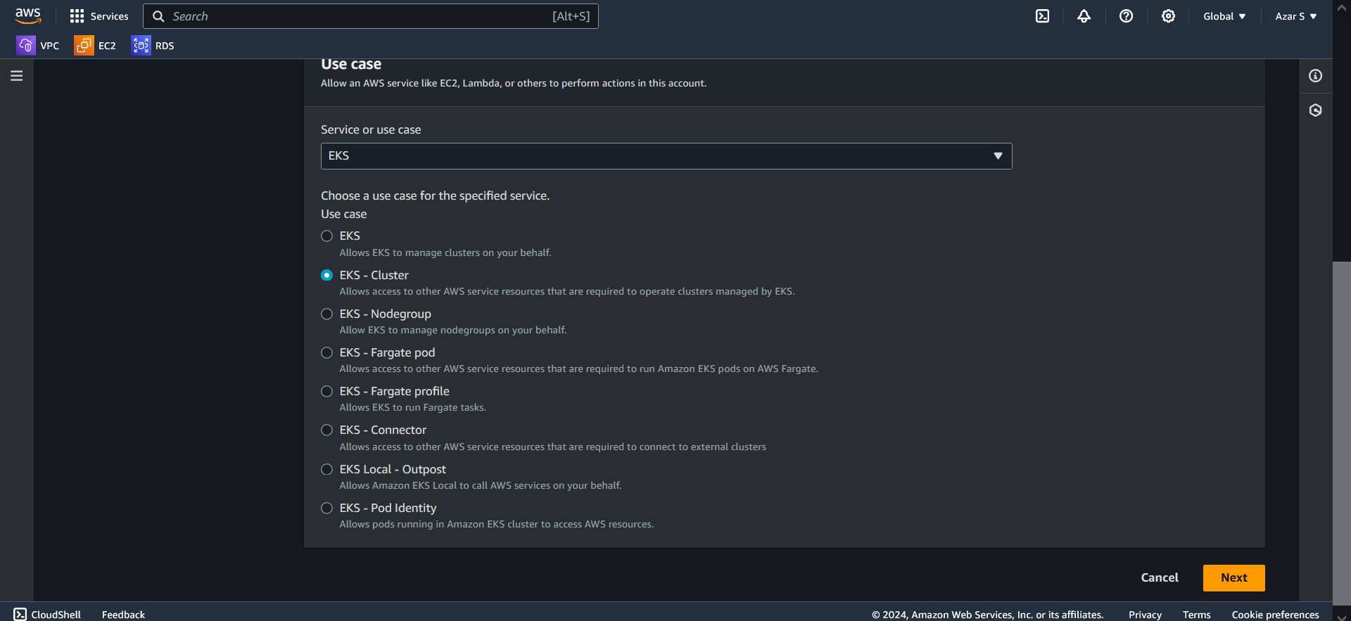 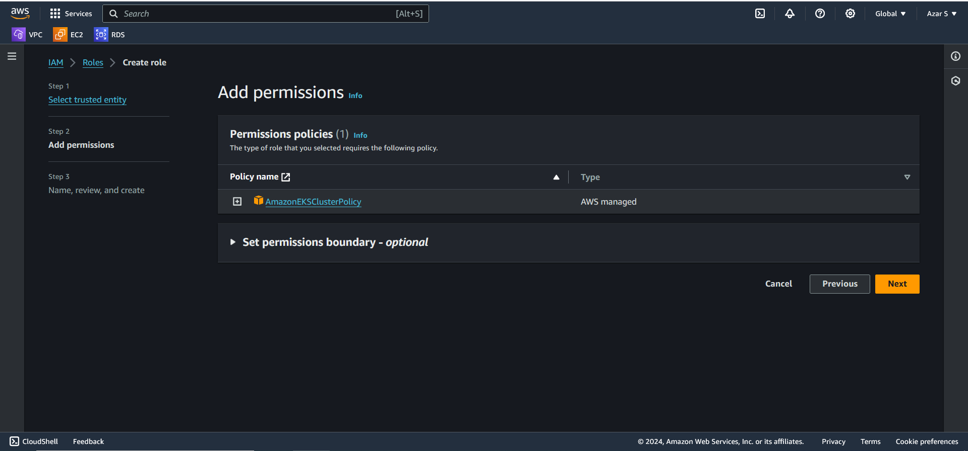 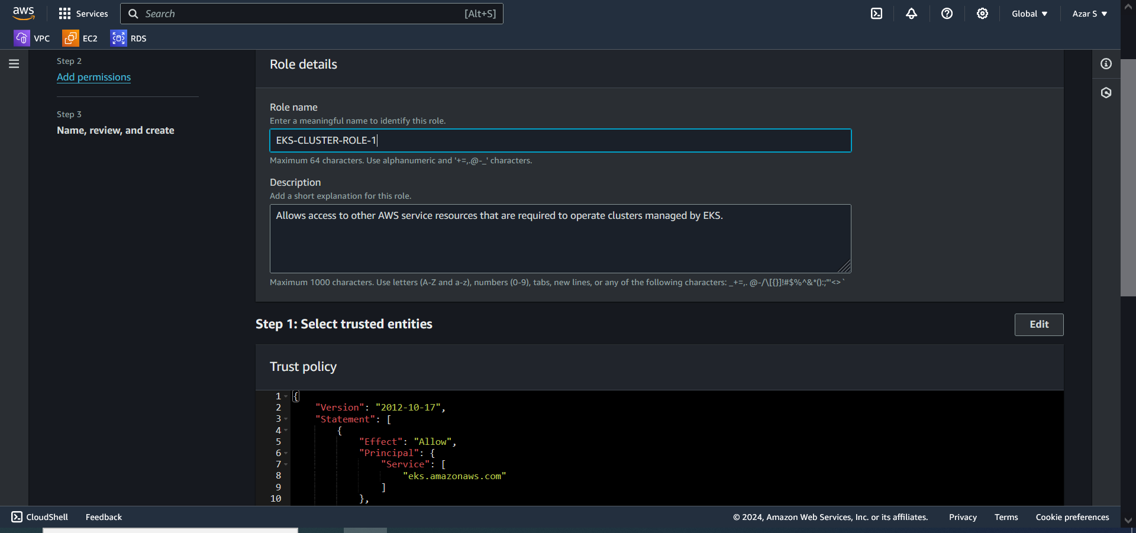 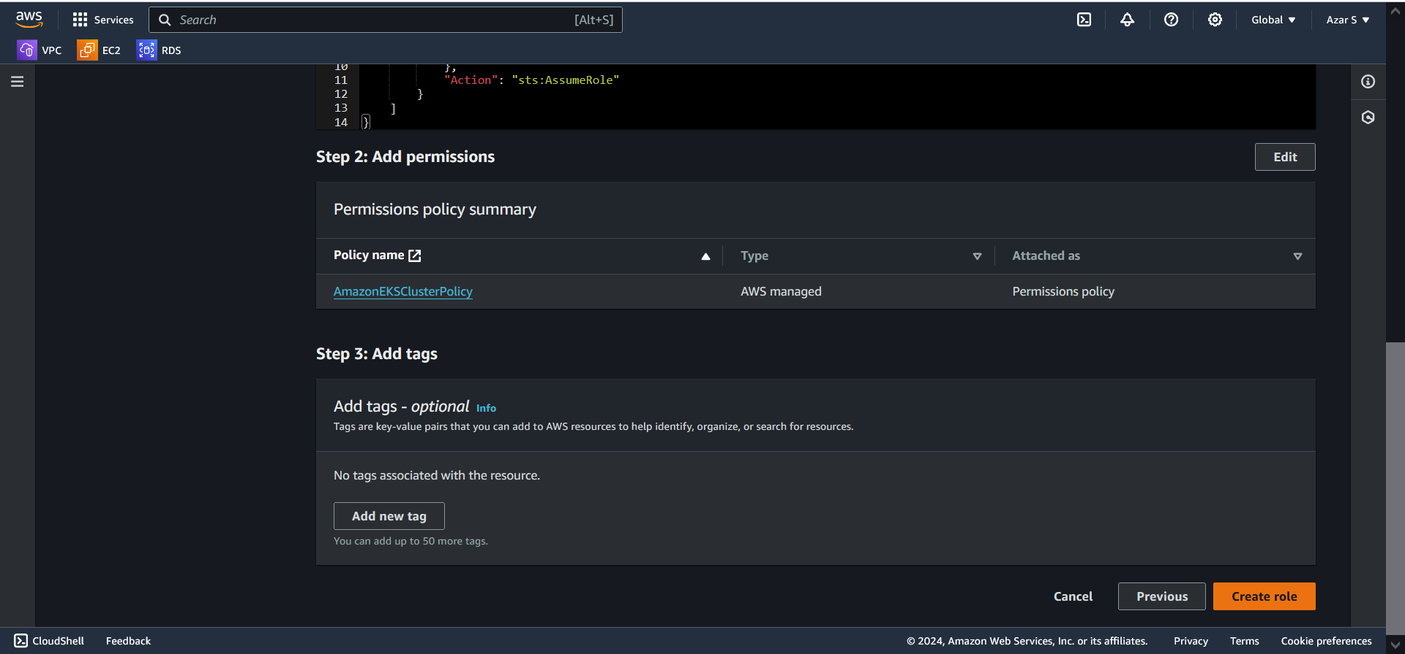

**CREATE ROLE FOR NODE-GROUP IN IAM**

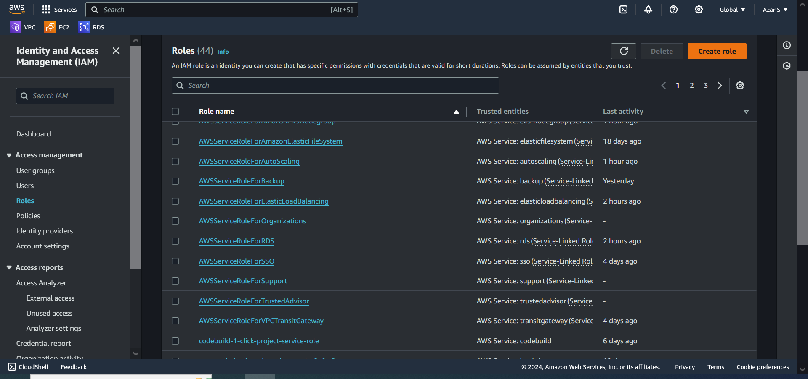 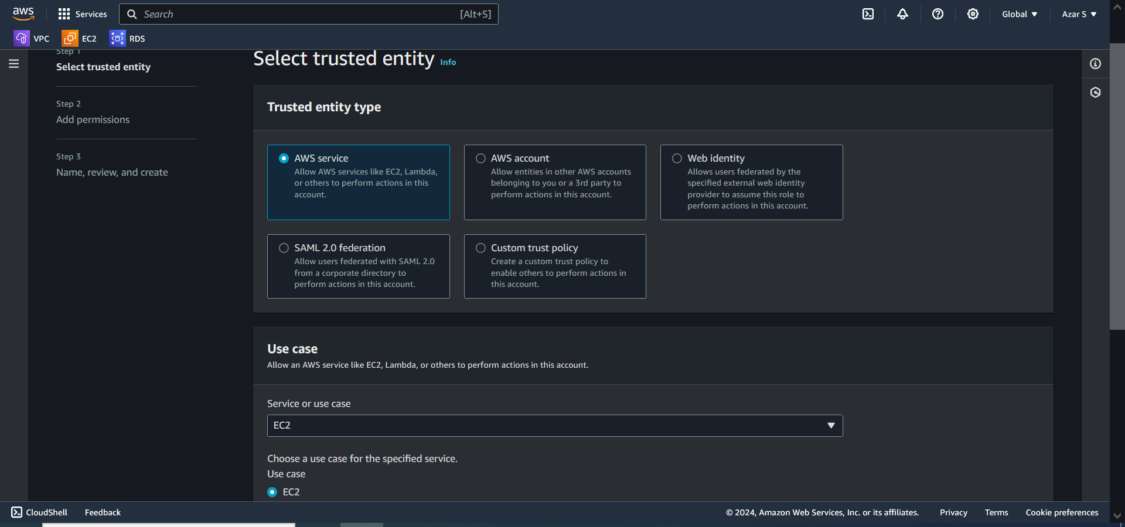 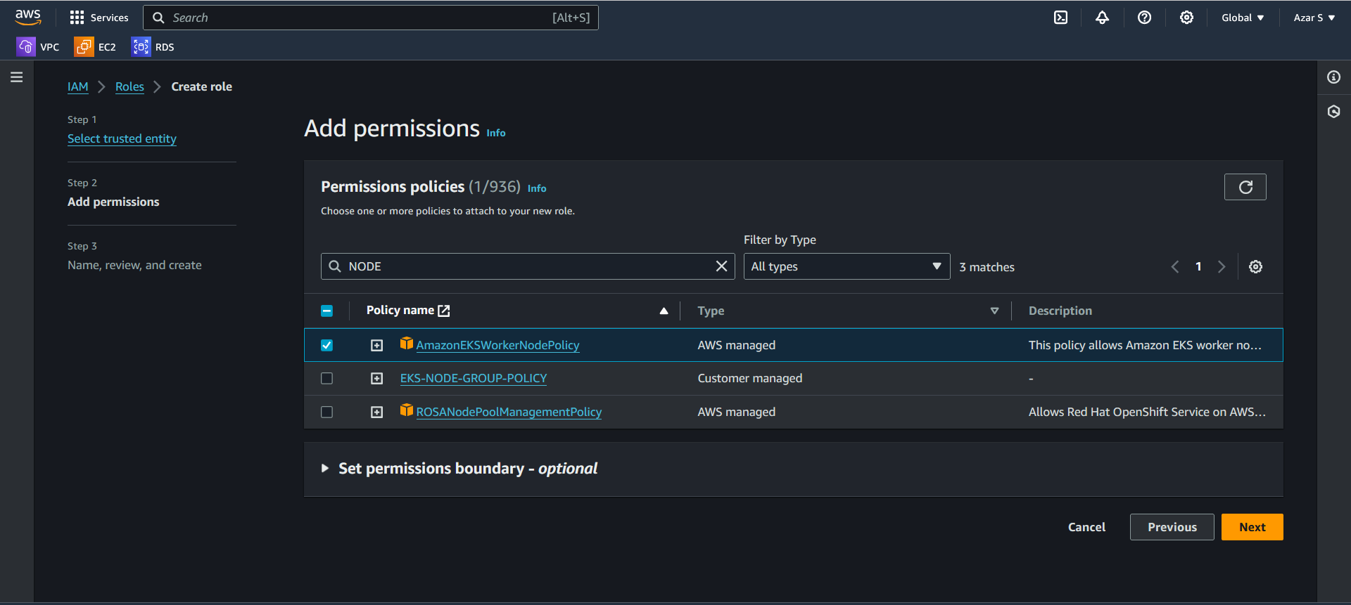 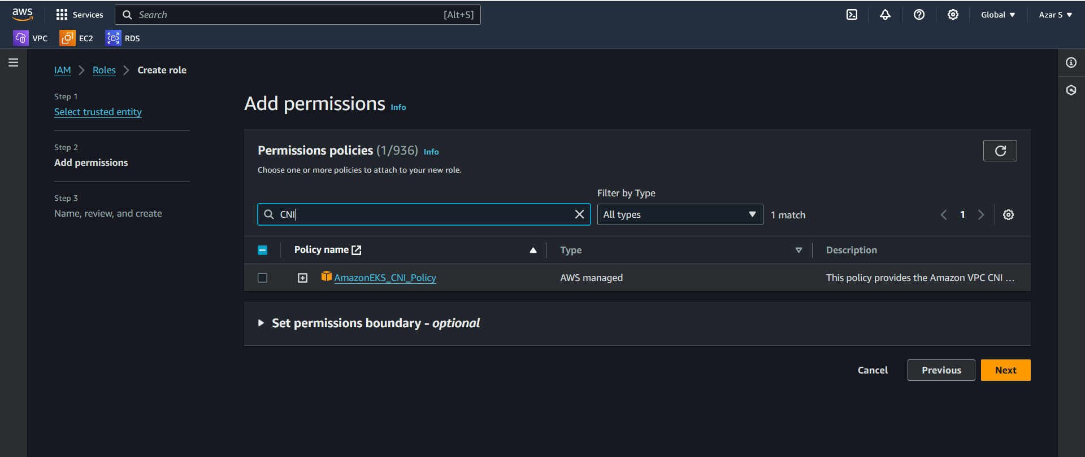 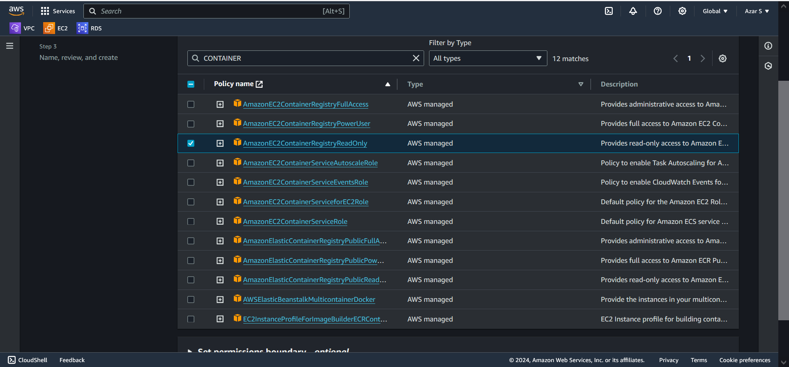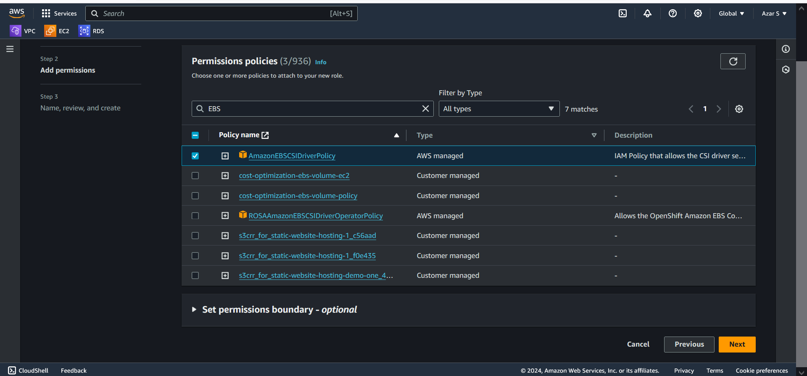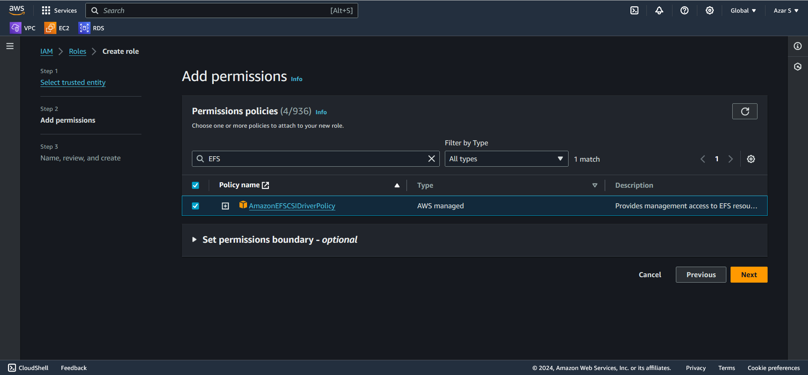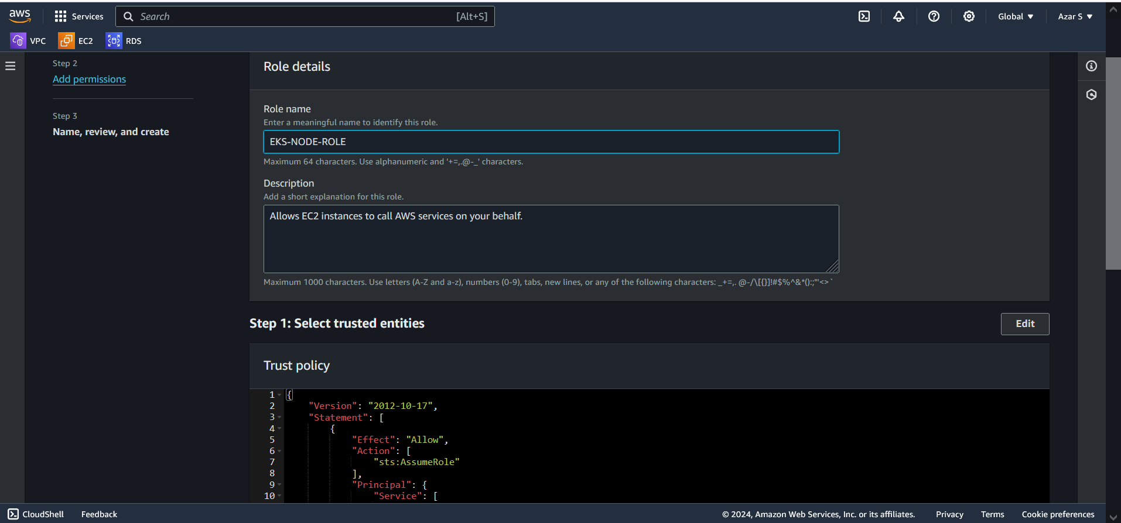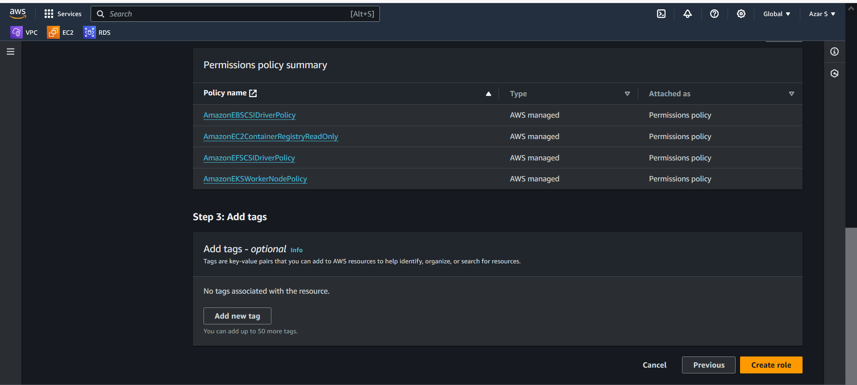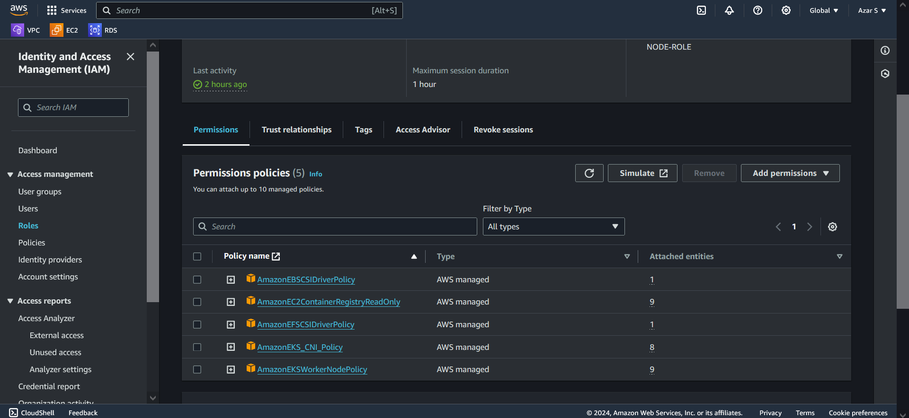

**CREATE CLUSTER IN EKS SERVICE:**

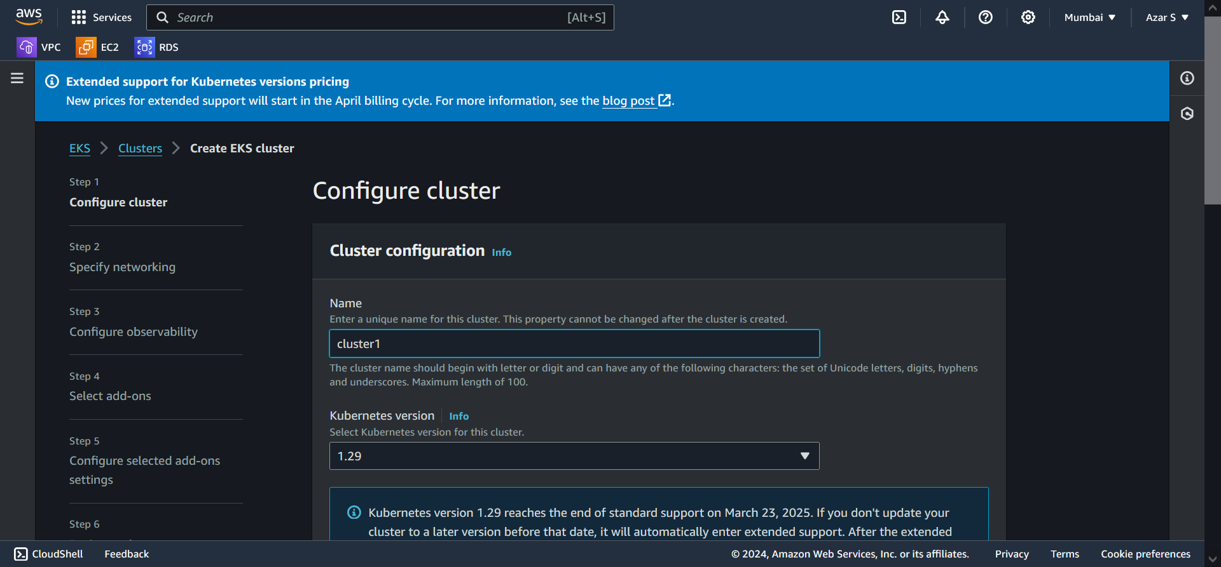 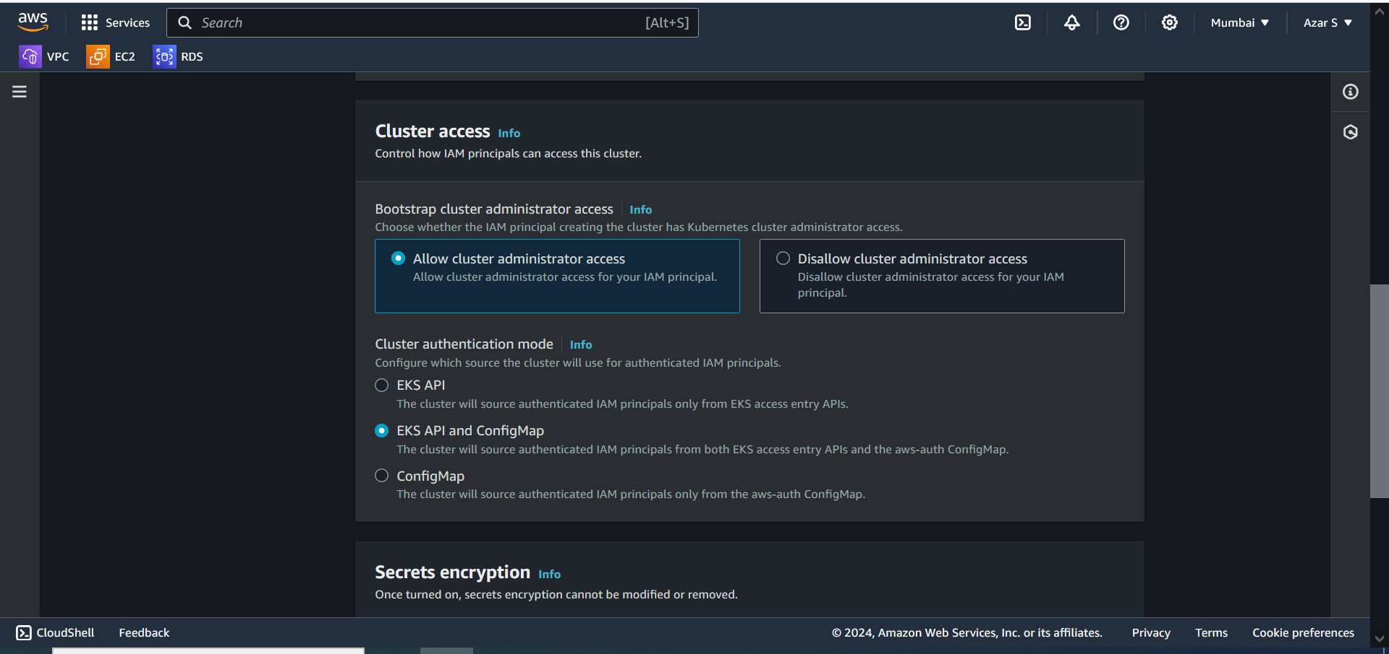 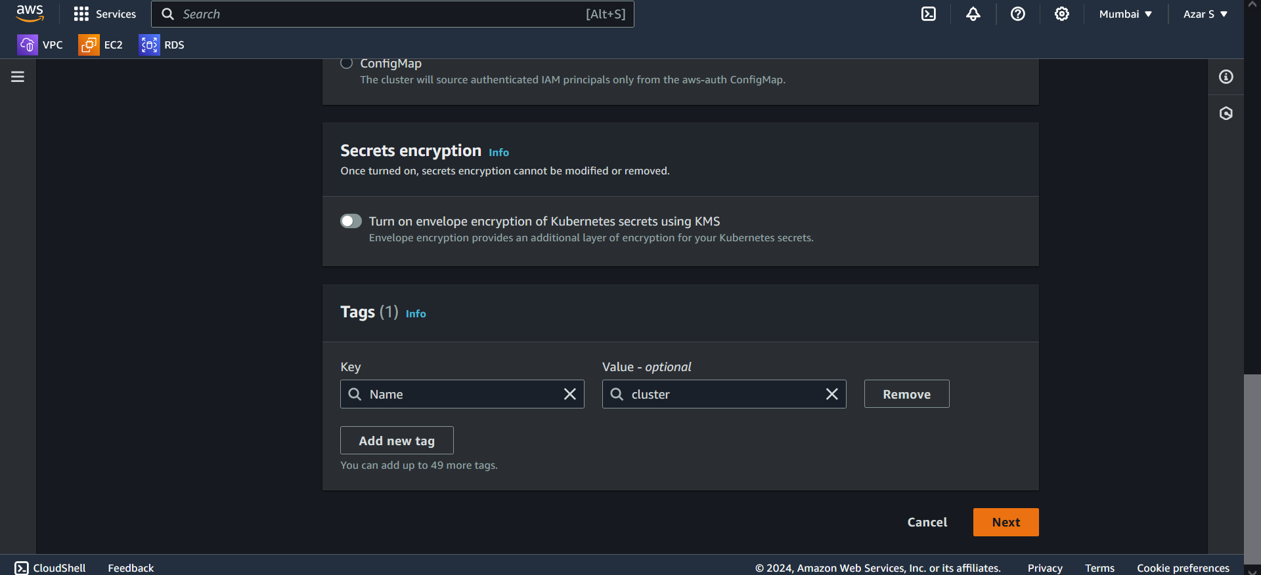 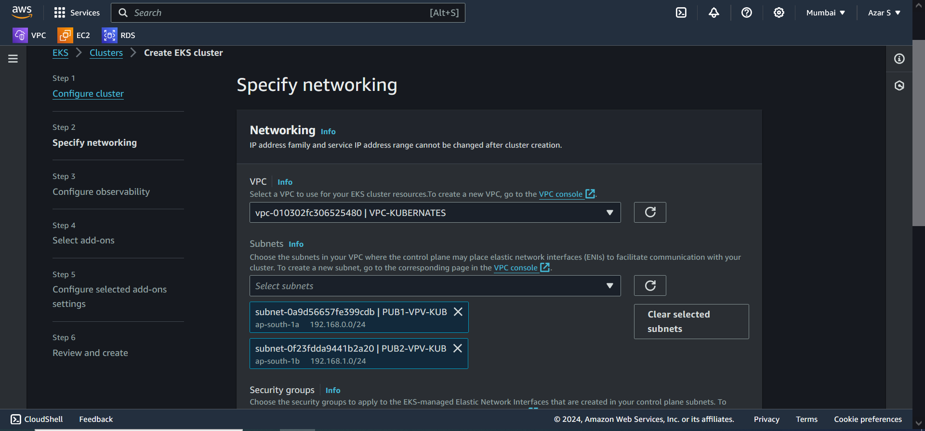 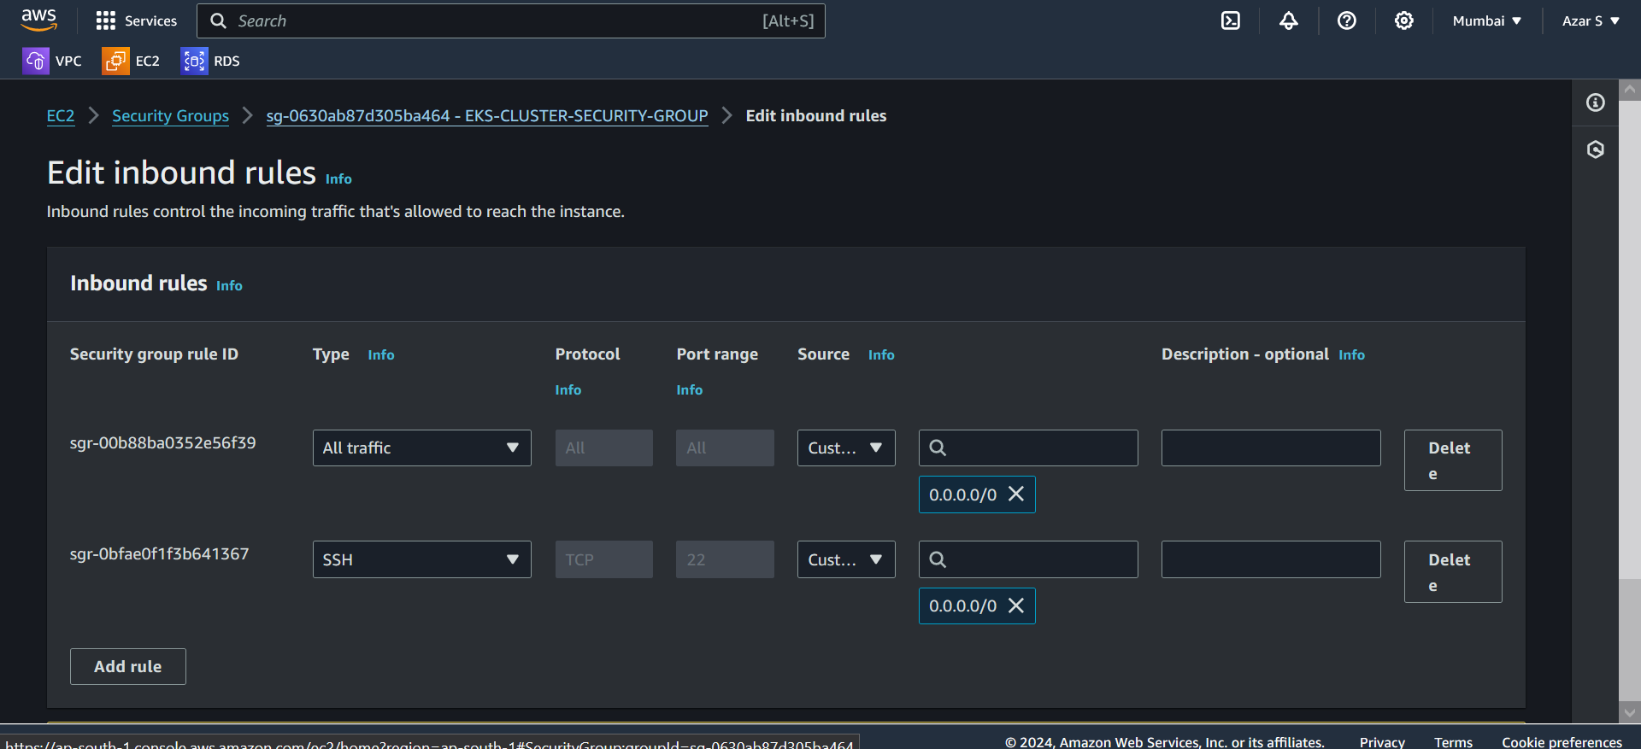 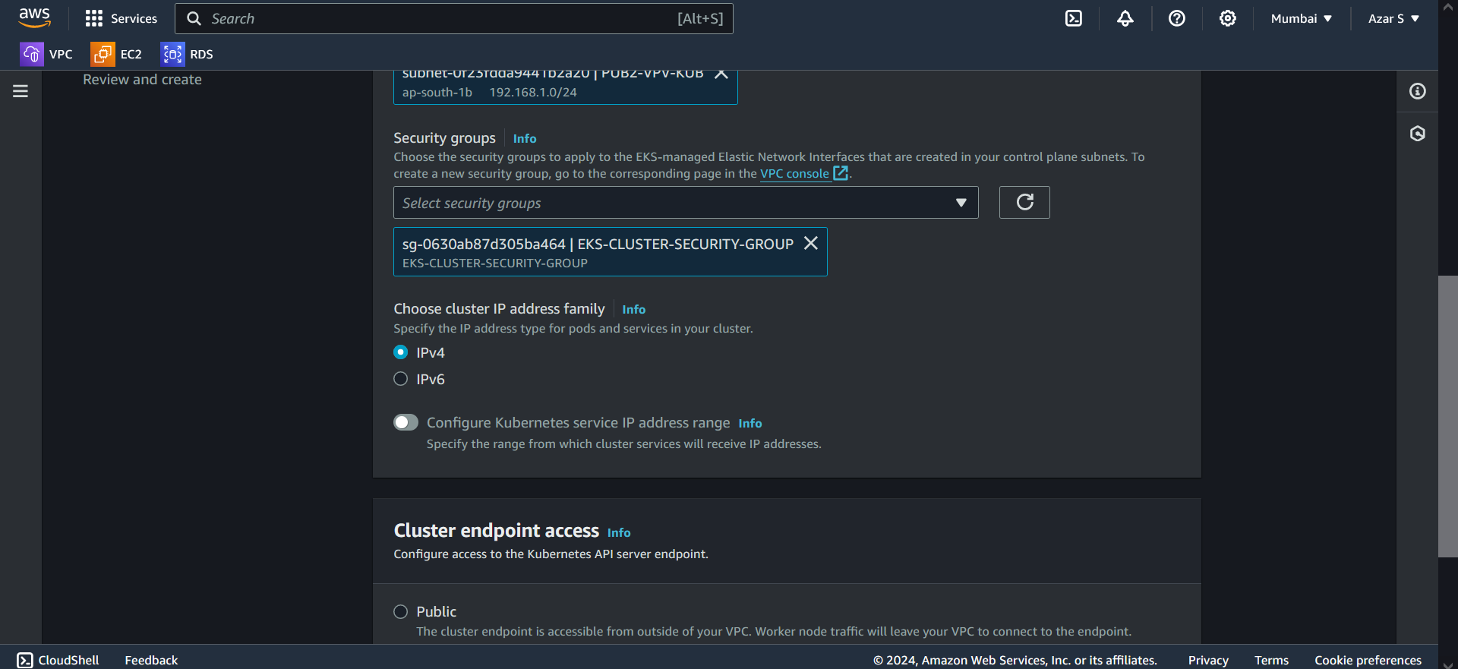 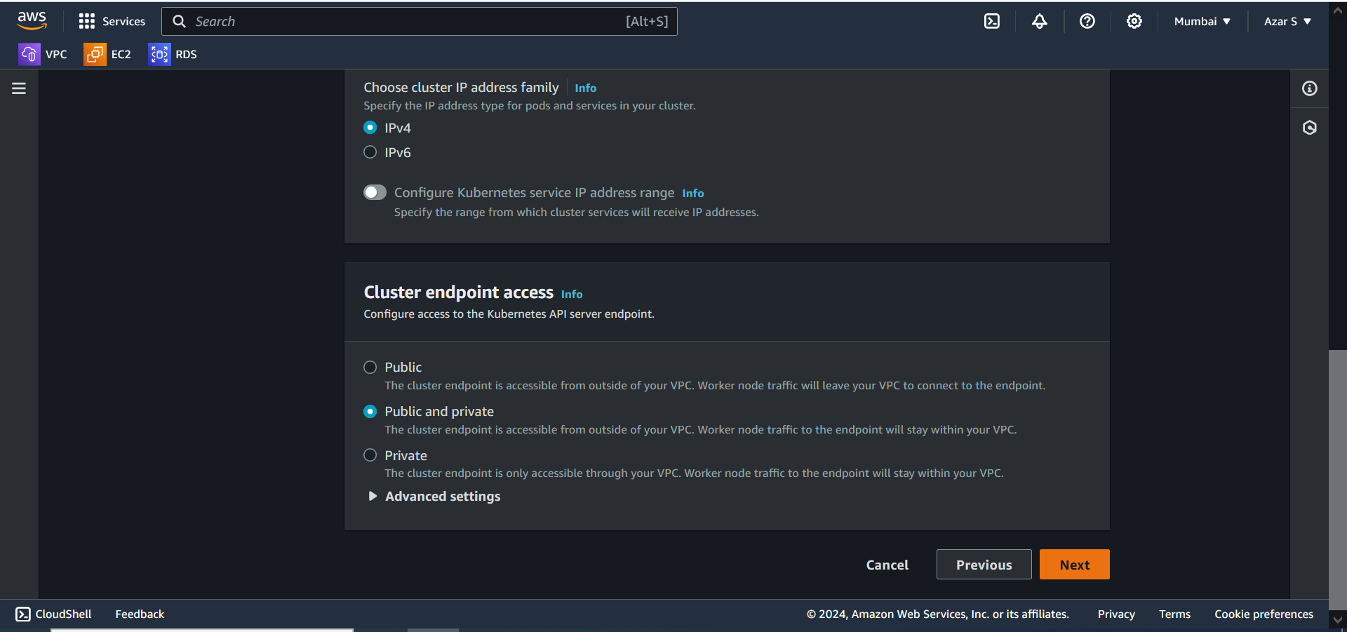 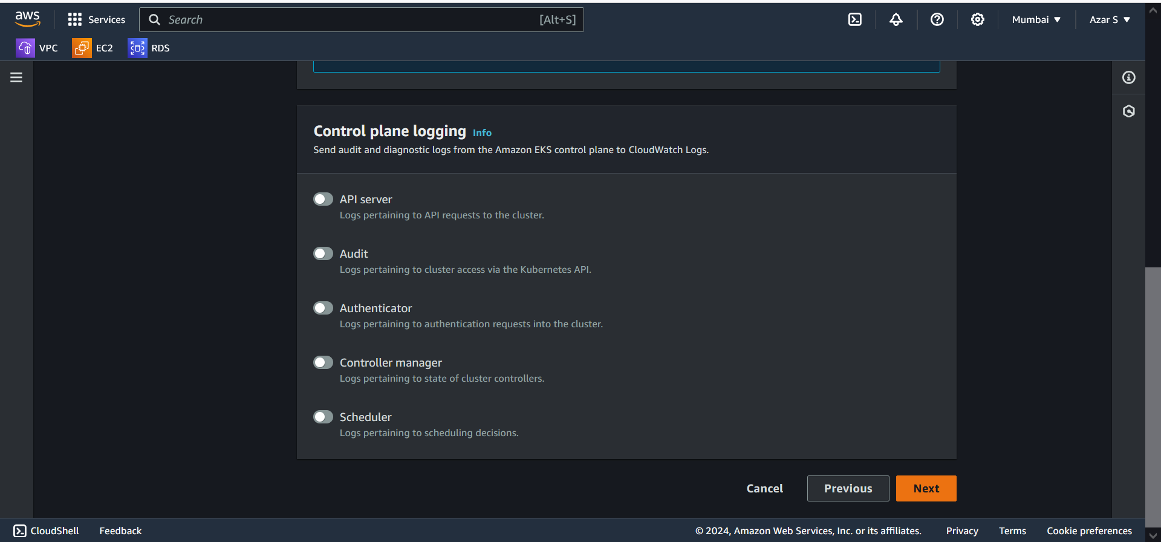 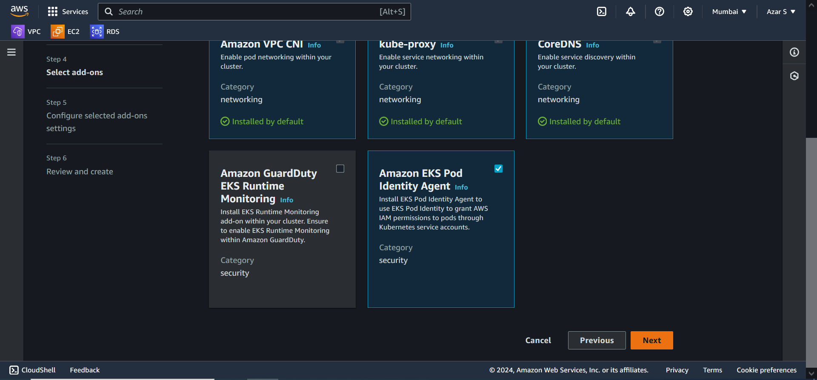 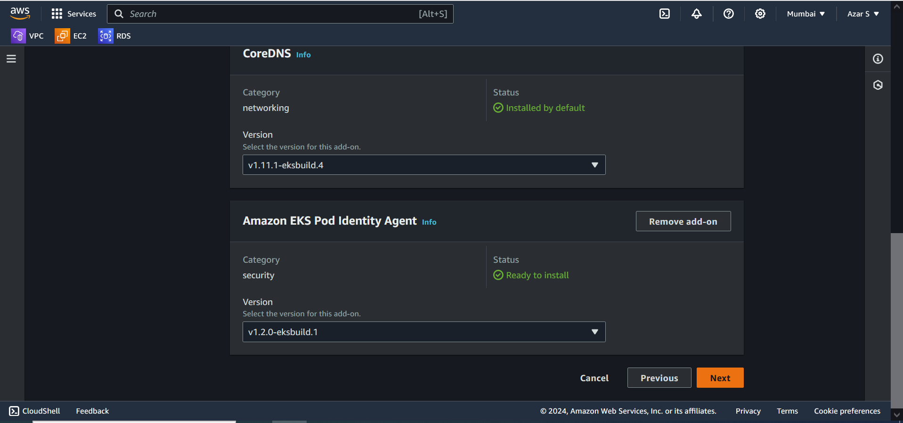 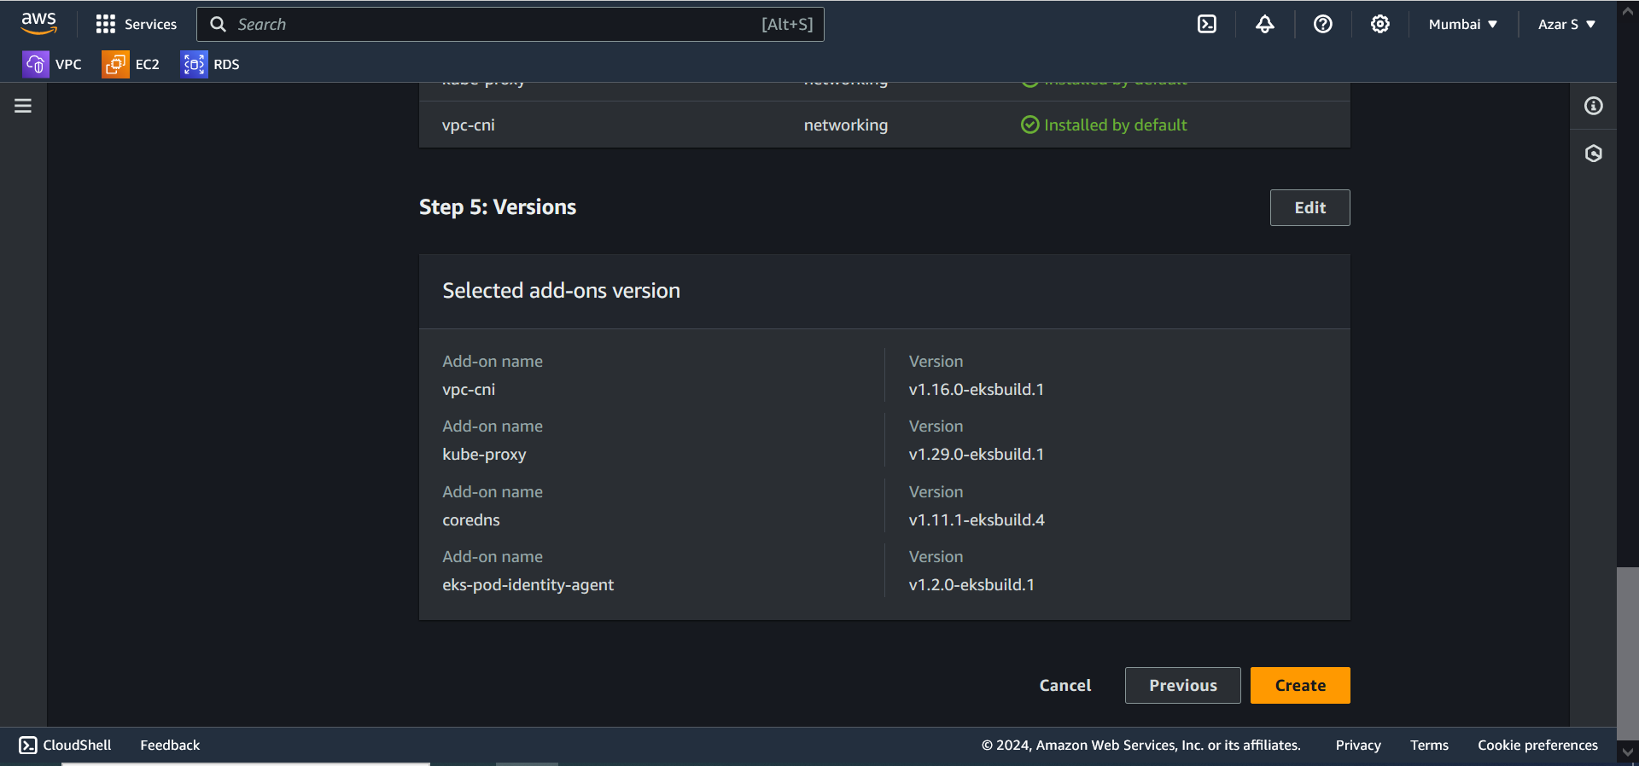

INSTALL AWS CLI ON WINDOWS:

LINK: <https://docs.aws.amazon.com/cli/latest/userguide/getting-started-install.html>

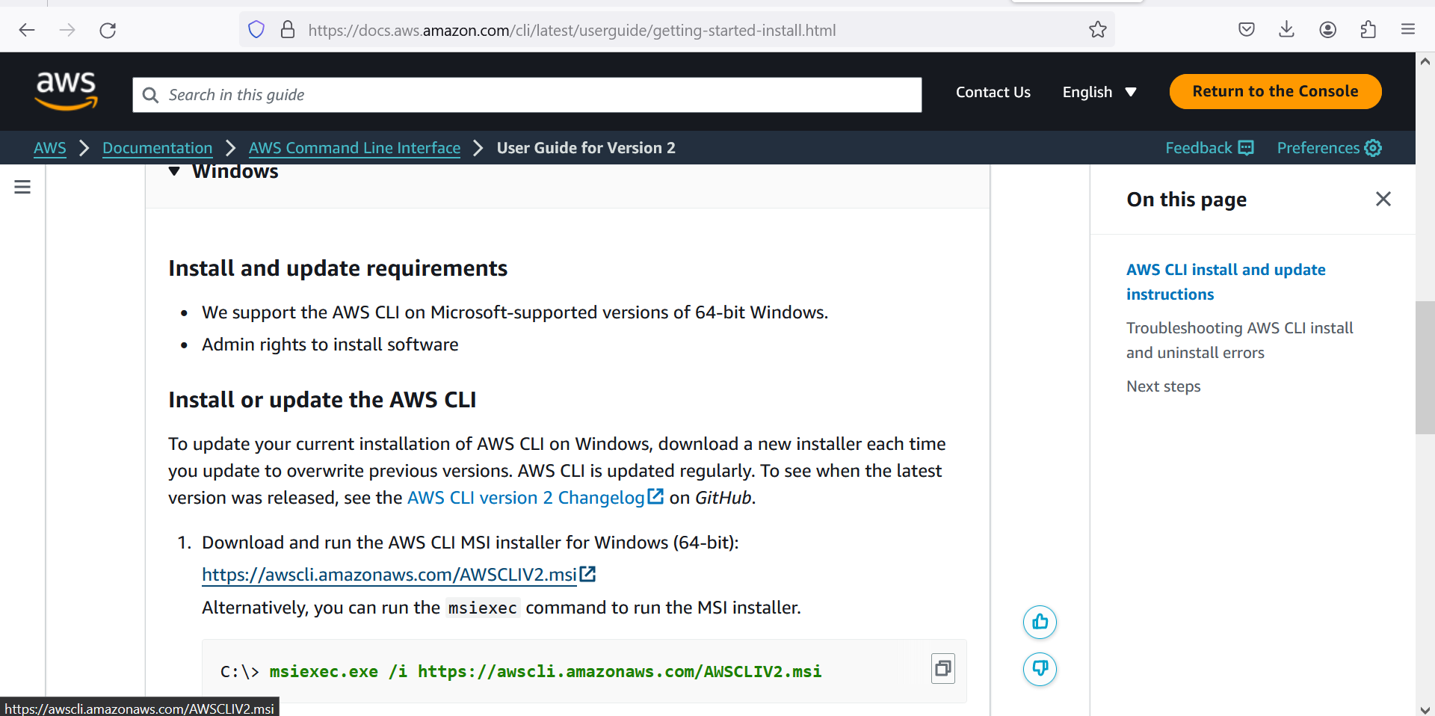

**INSTALL KUBECTL ON WINDOWS:**

LINK: <https://docs.aws.amazon.com/eks/latest/userguide/install-kubectl.html>

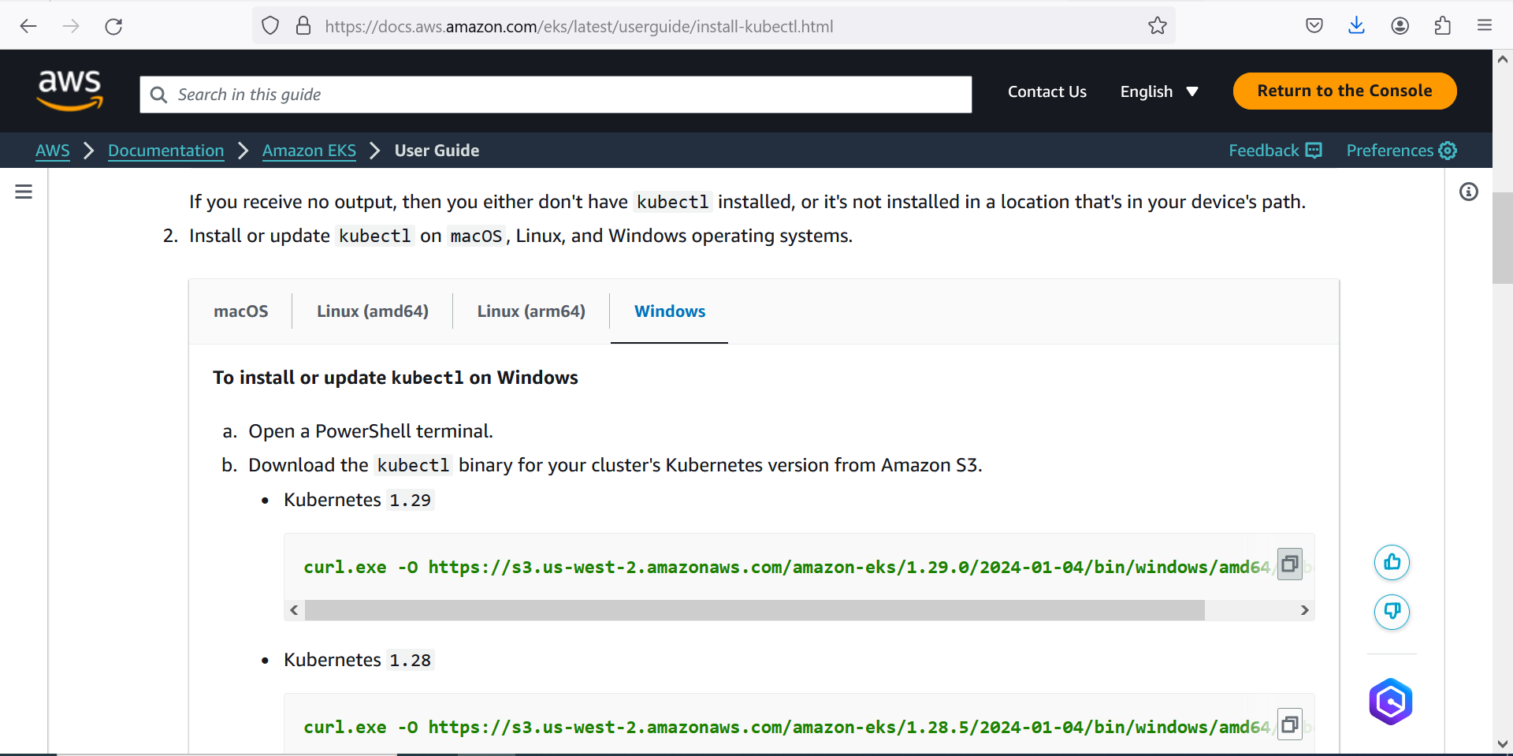

**RUN COMMAND IN COMMAND PROMPT**

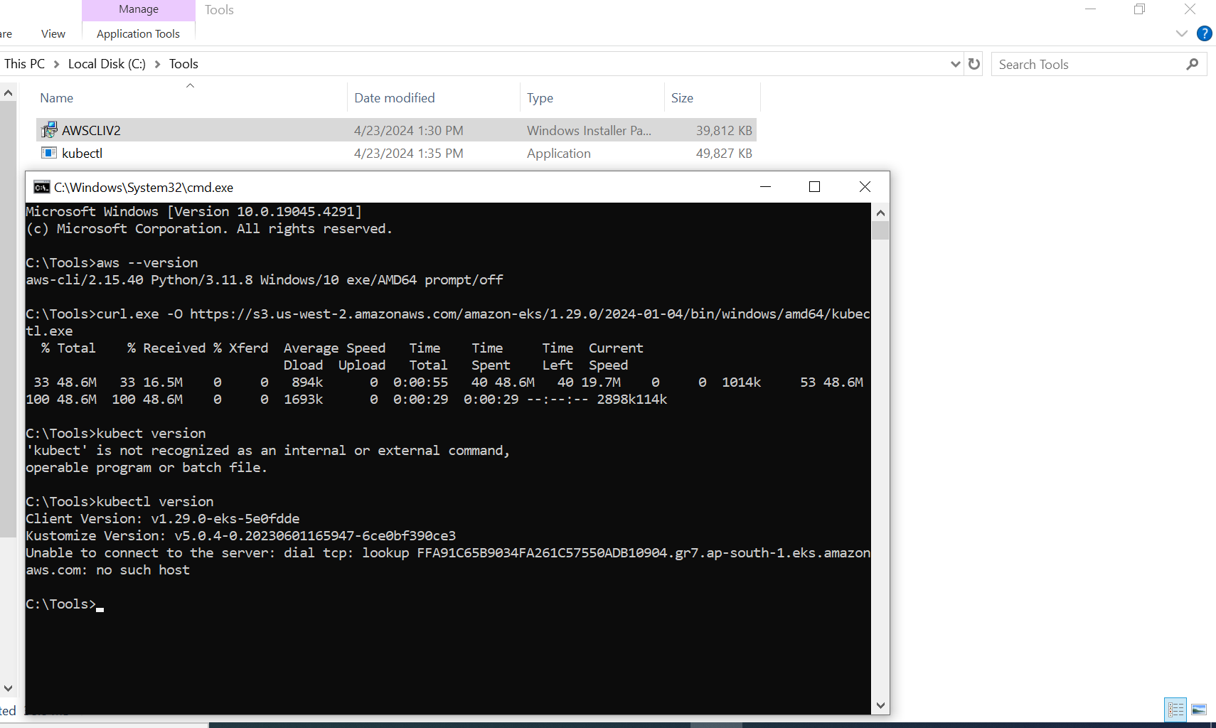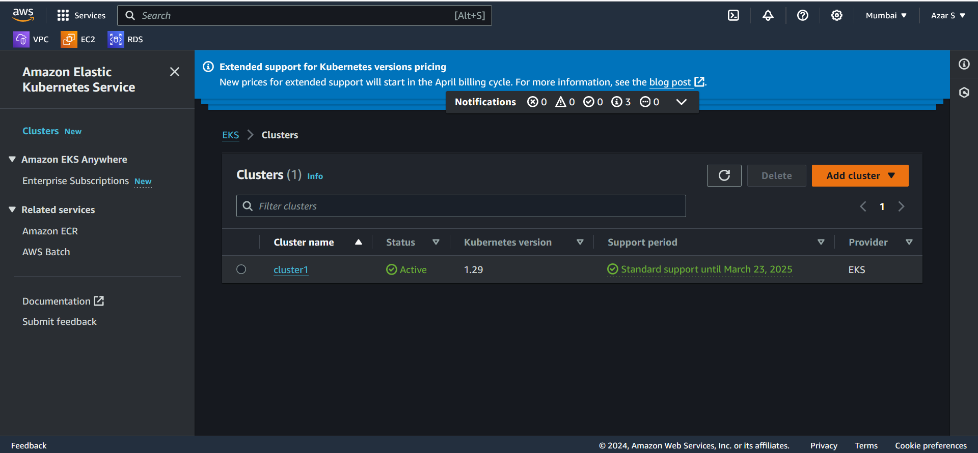

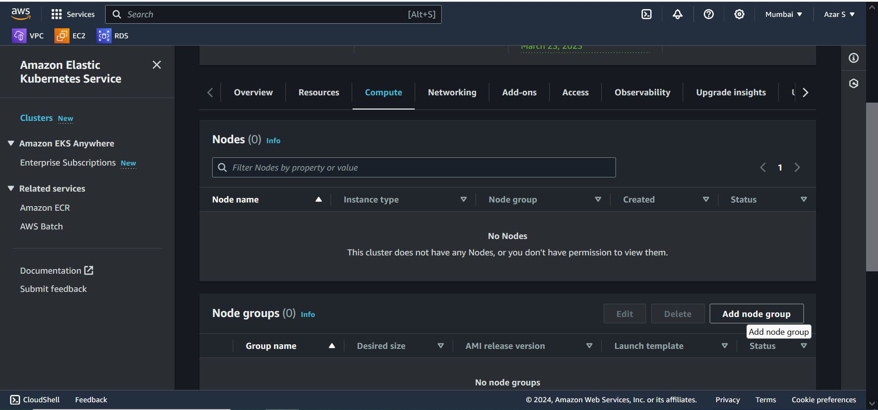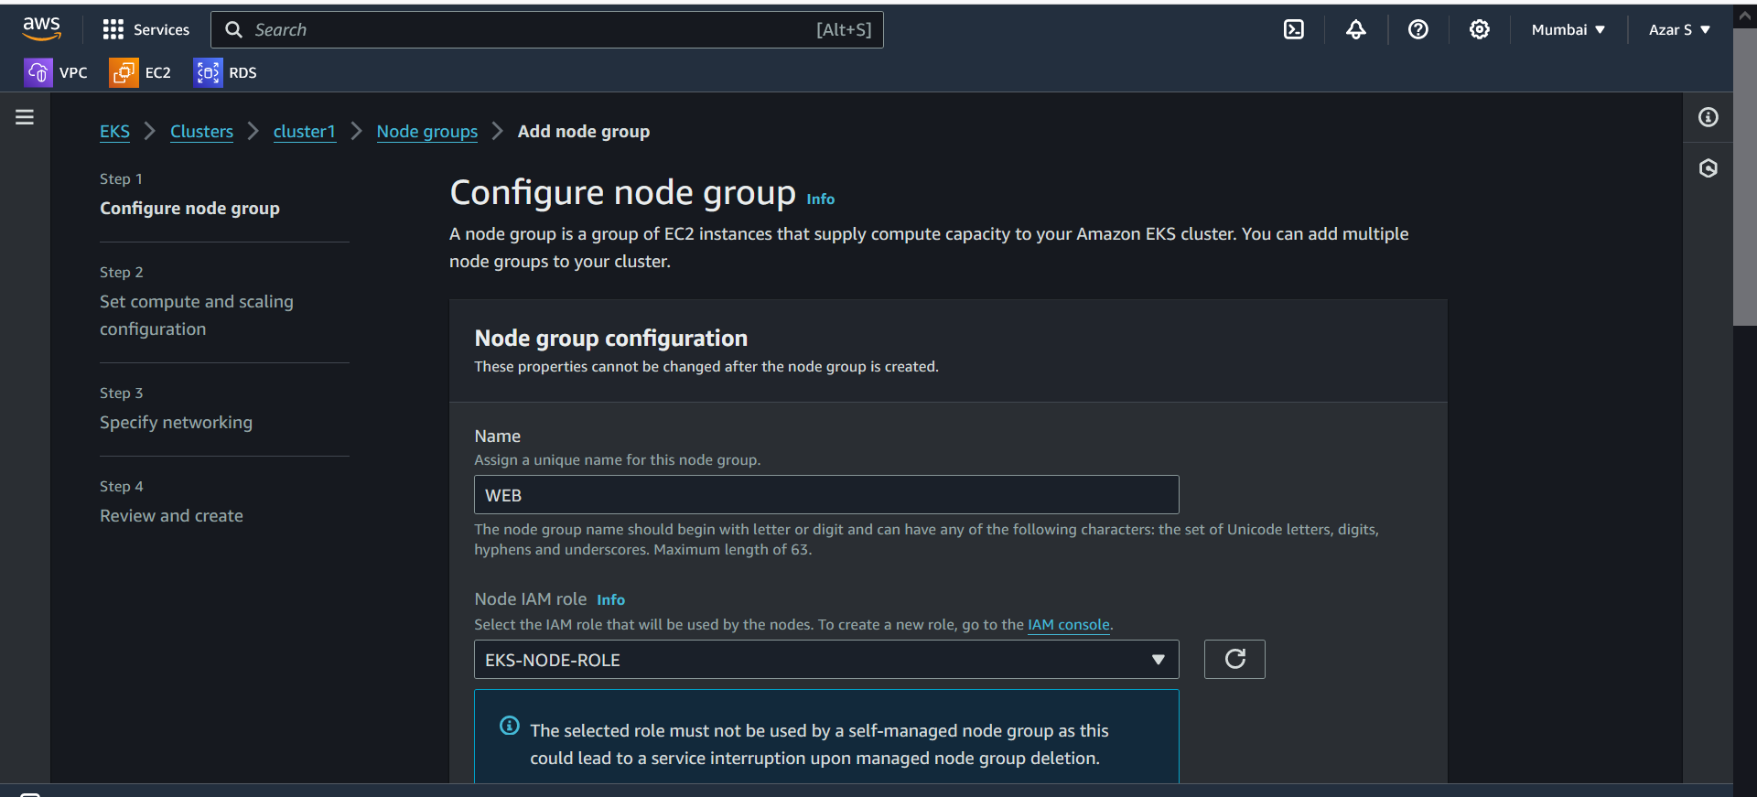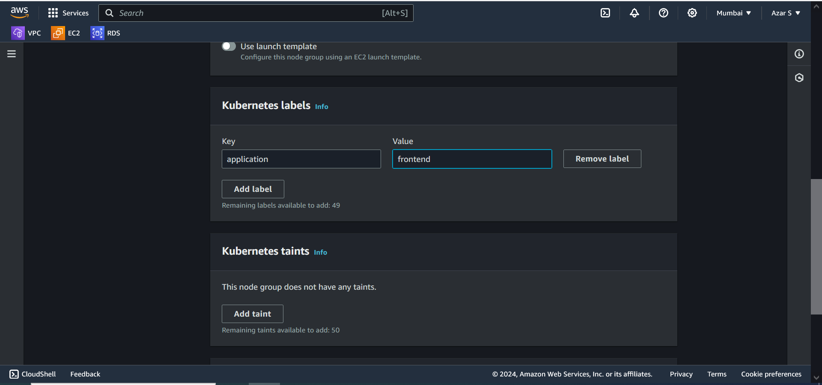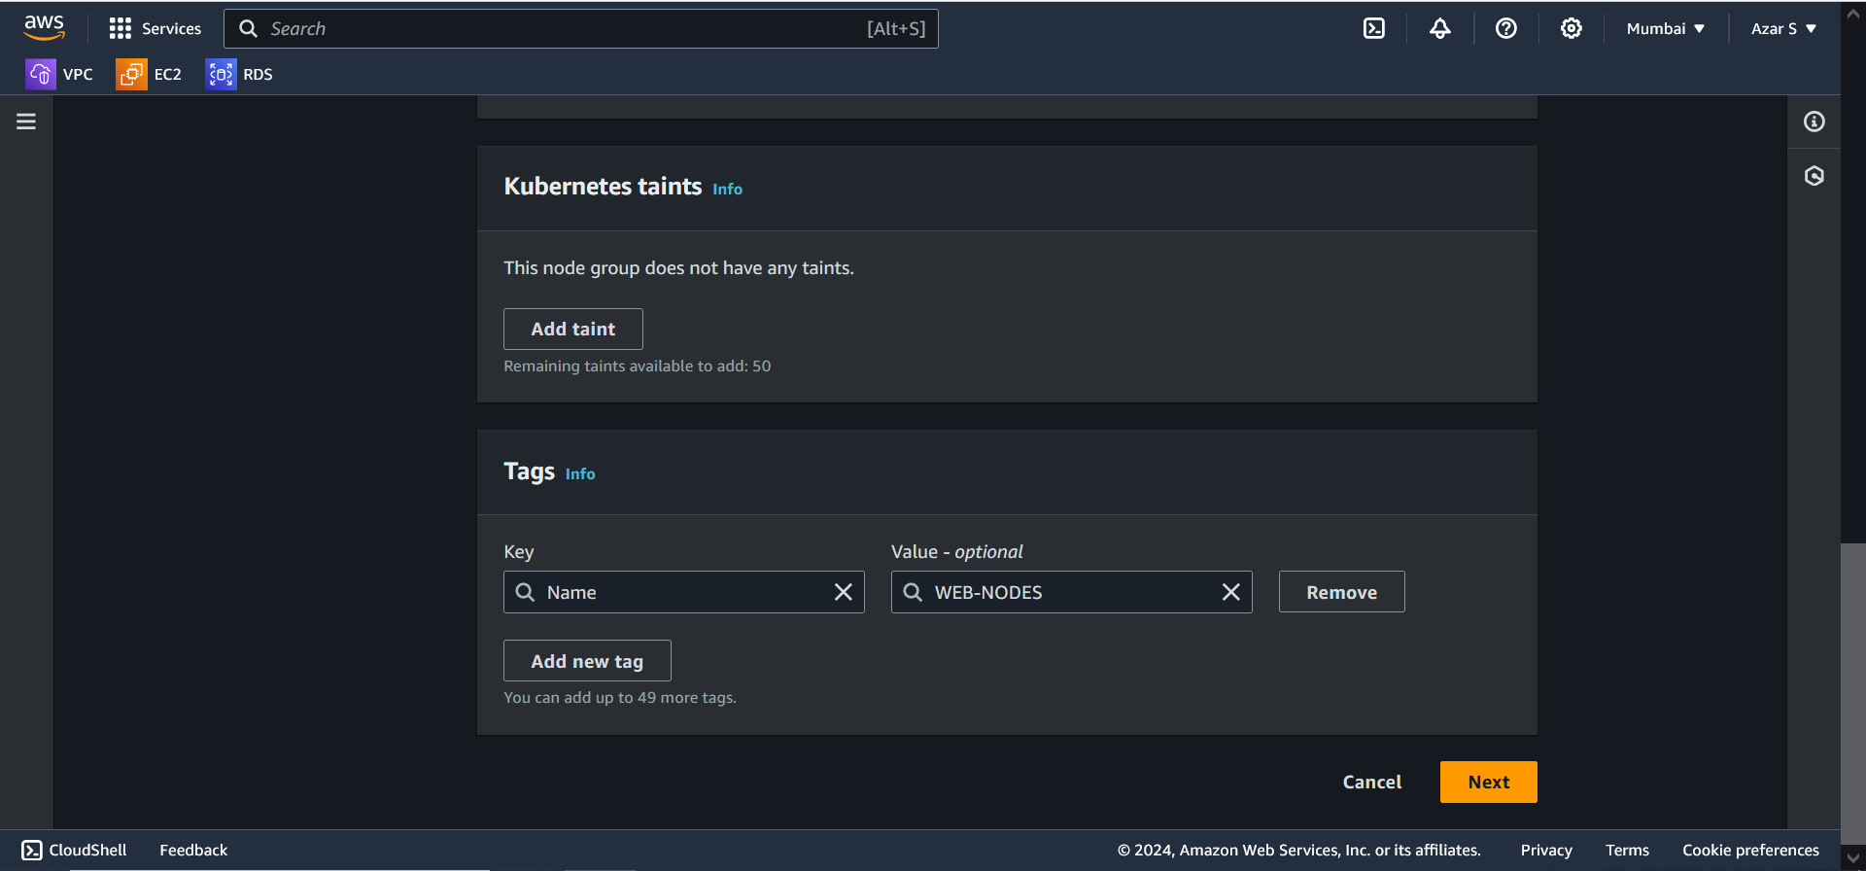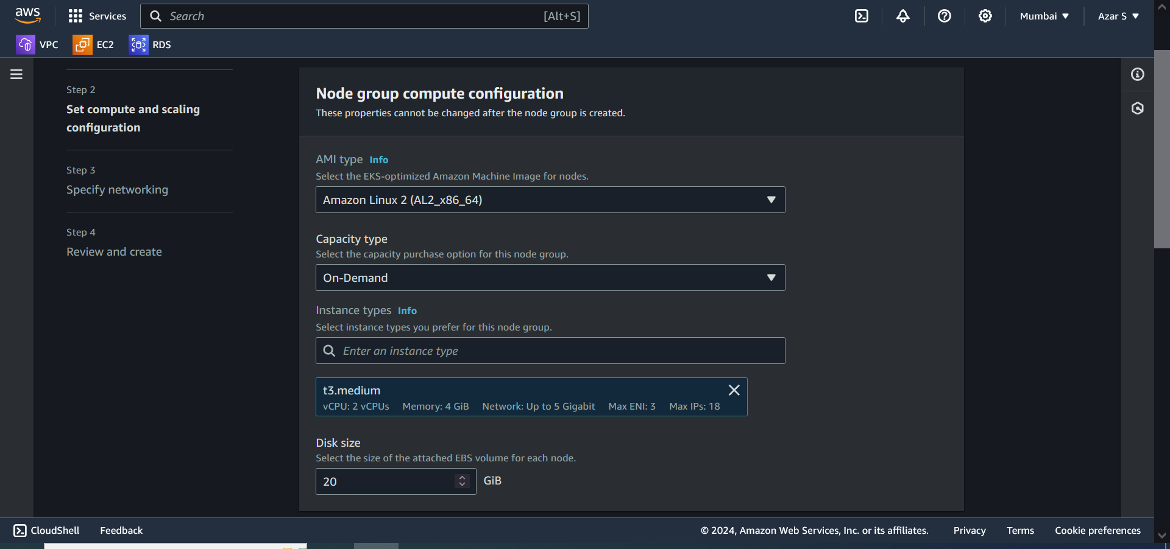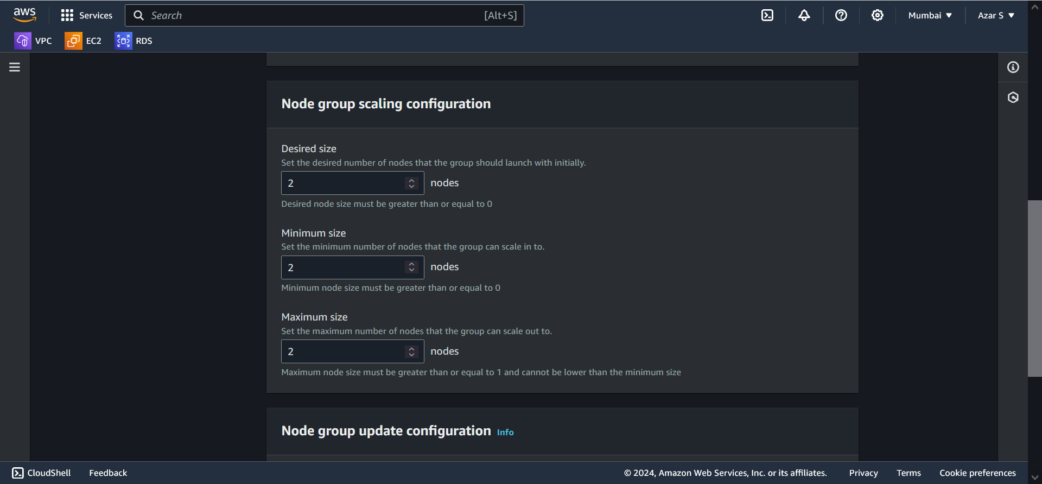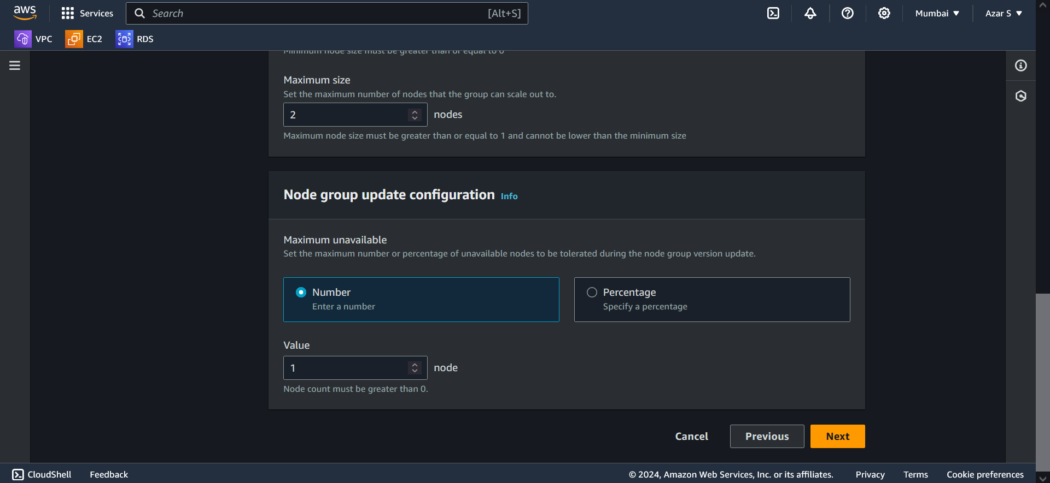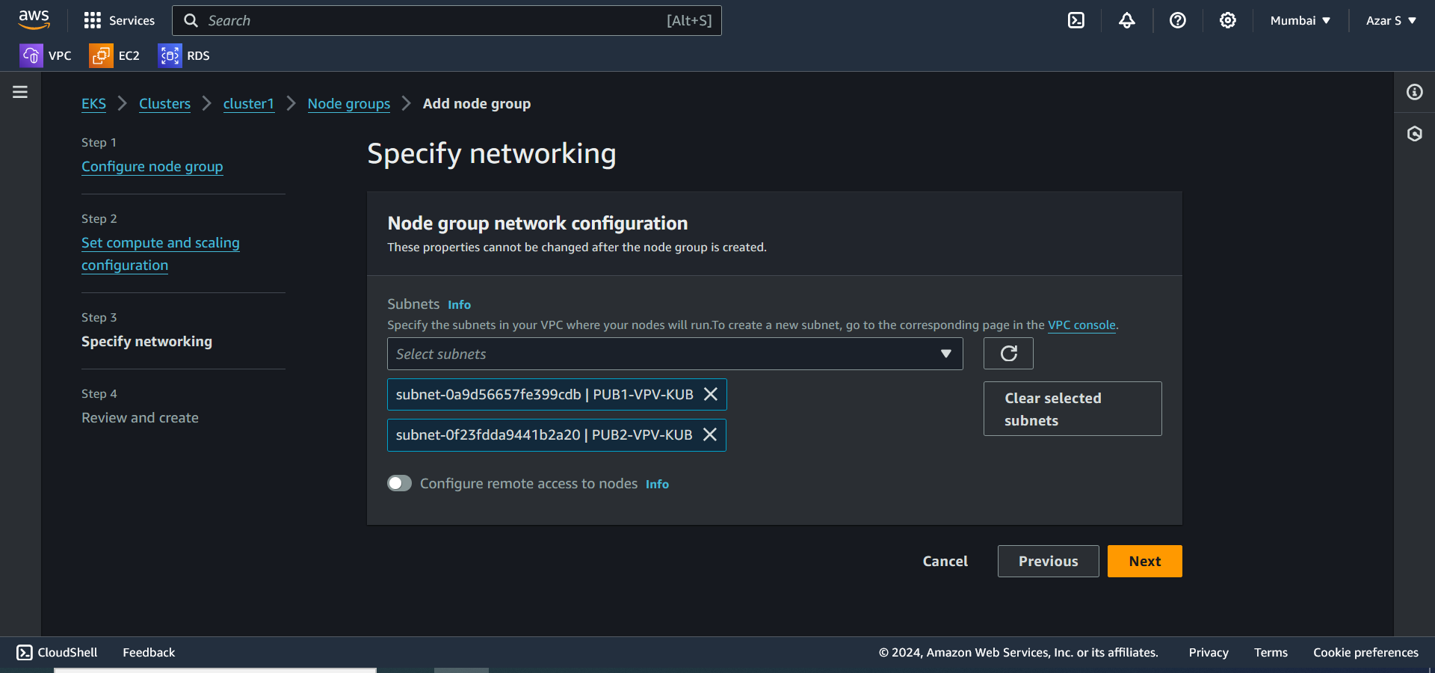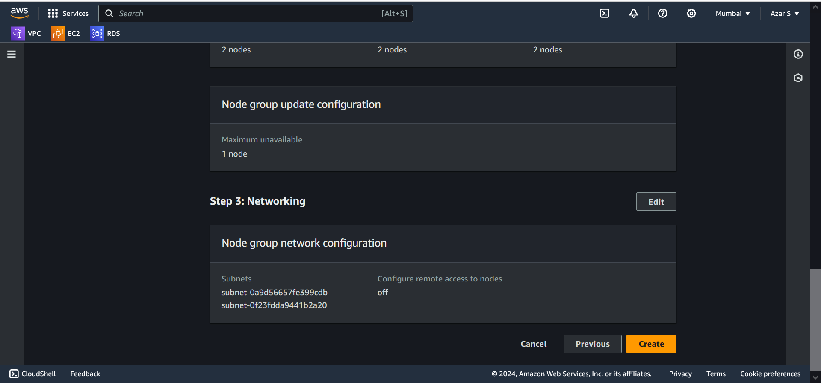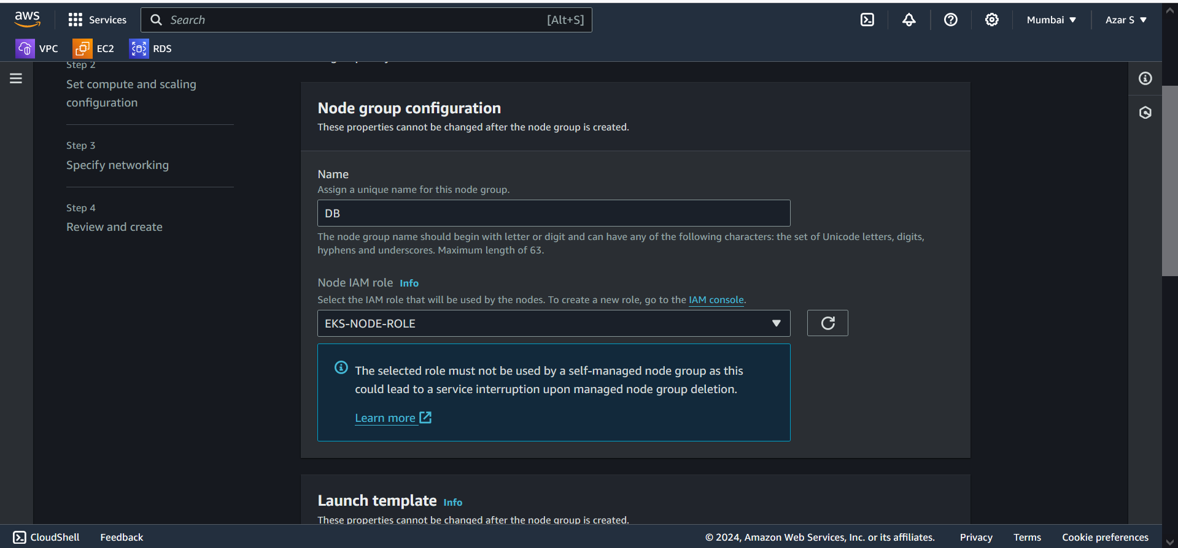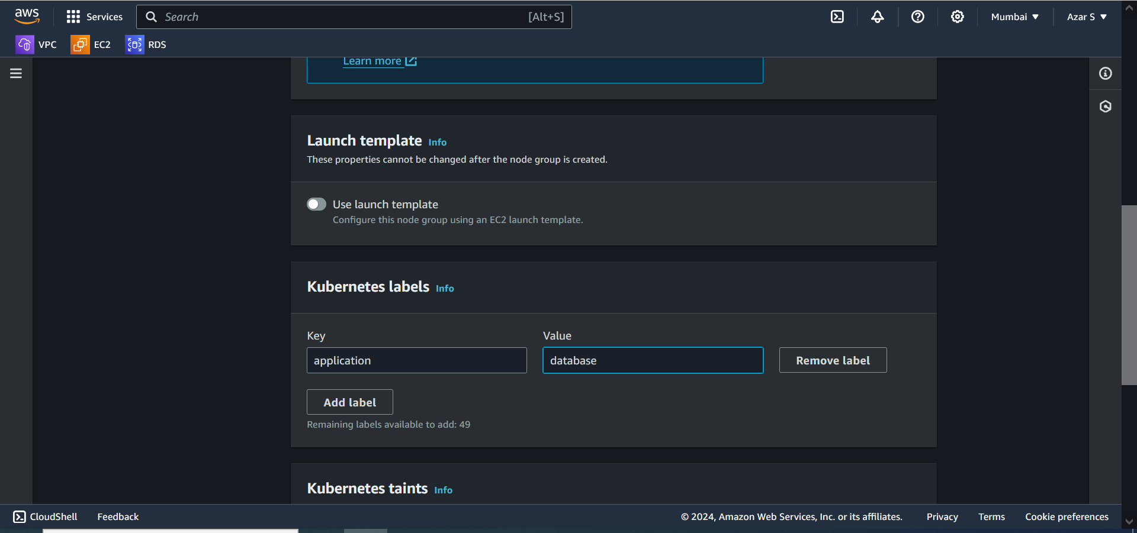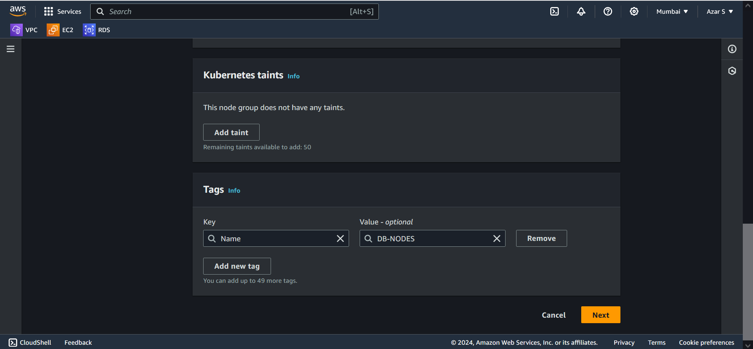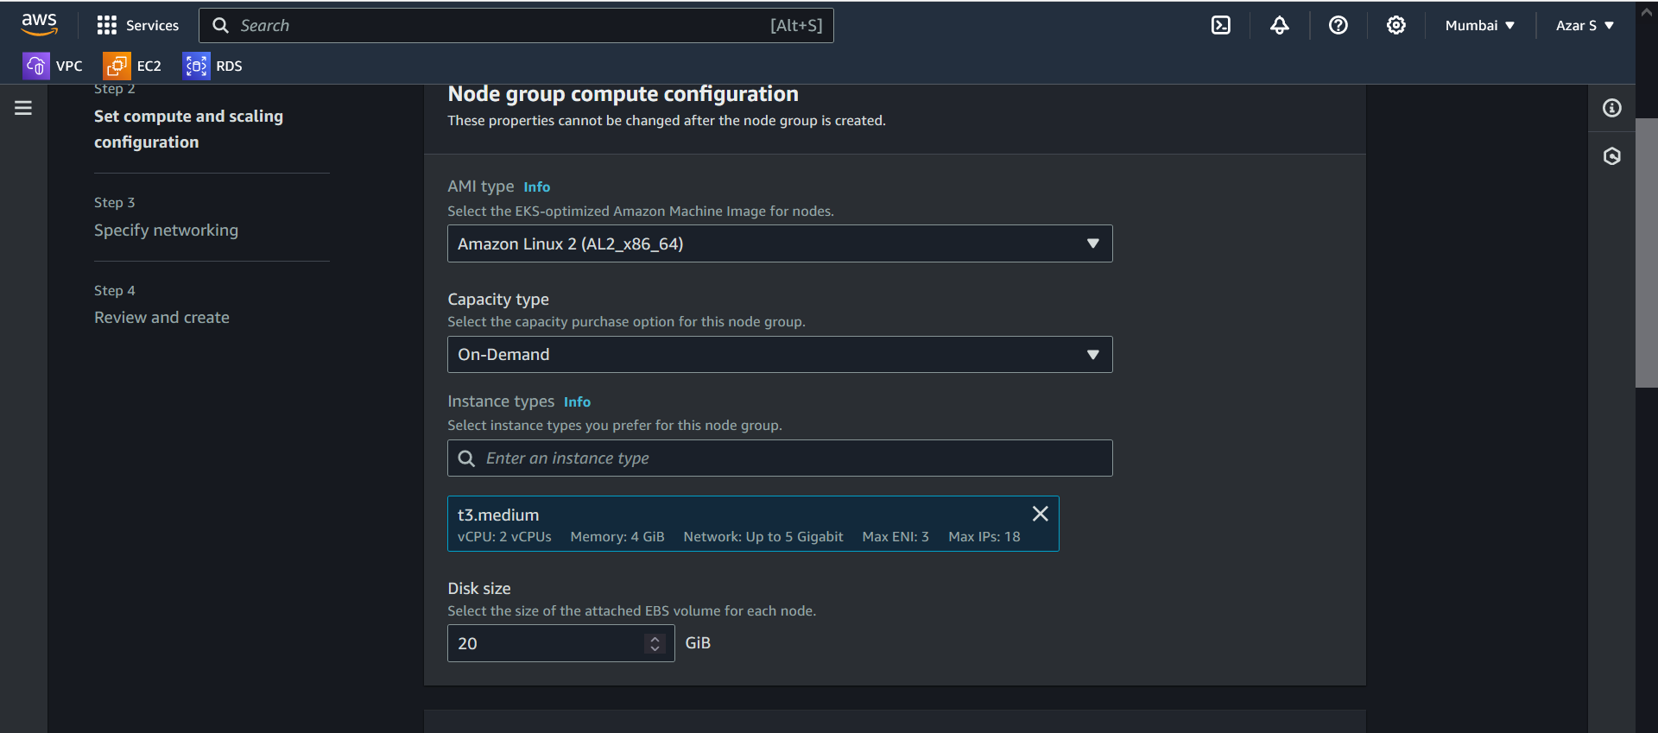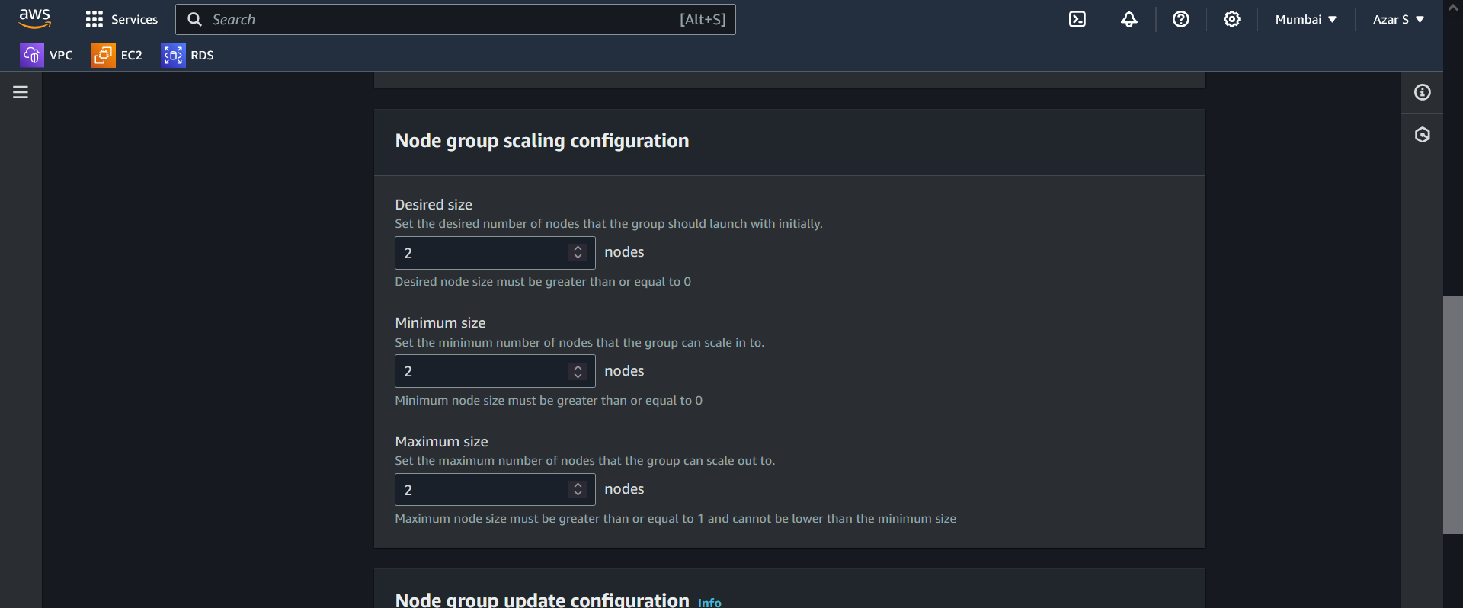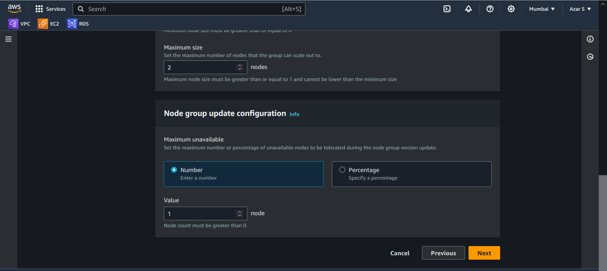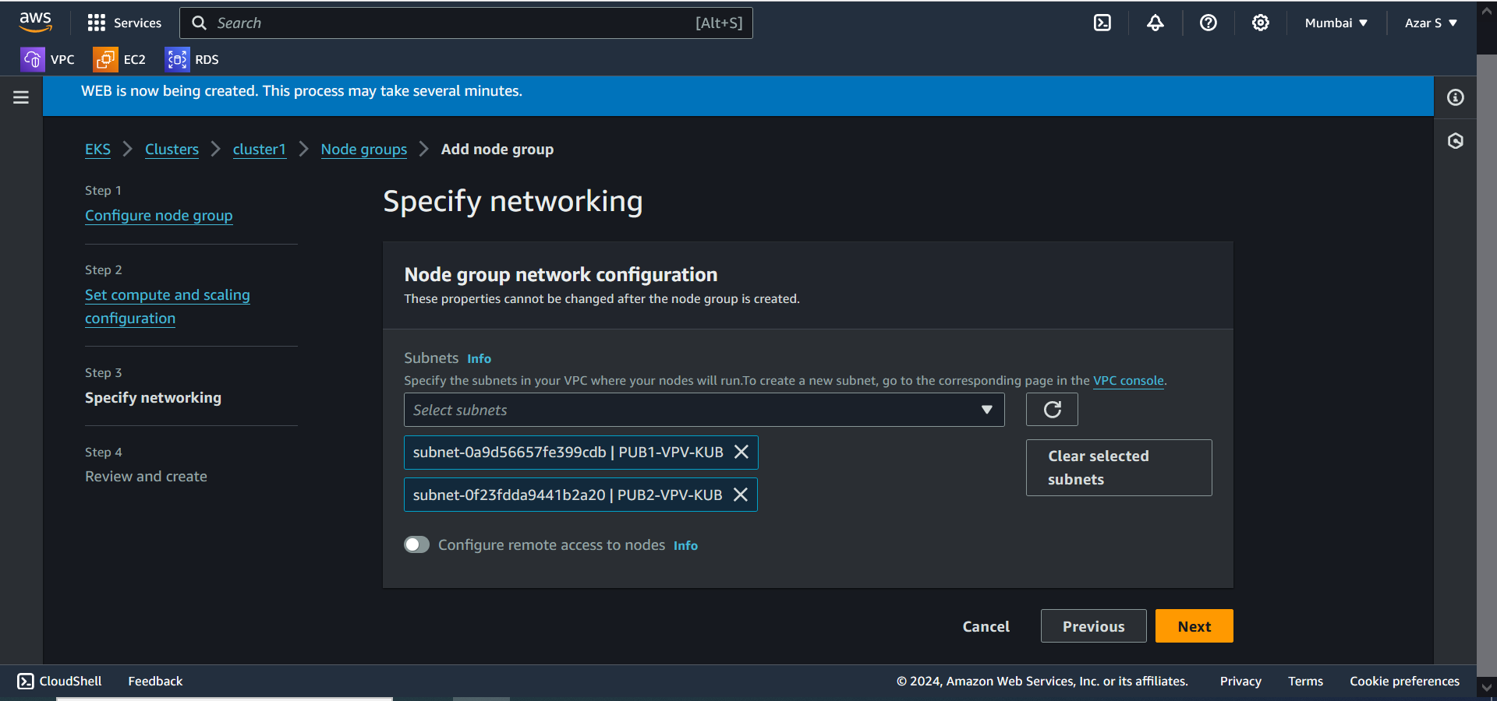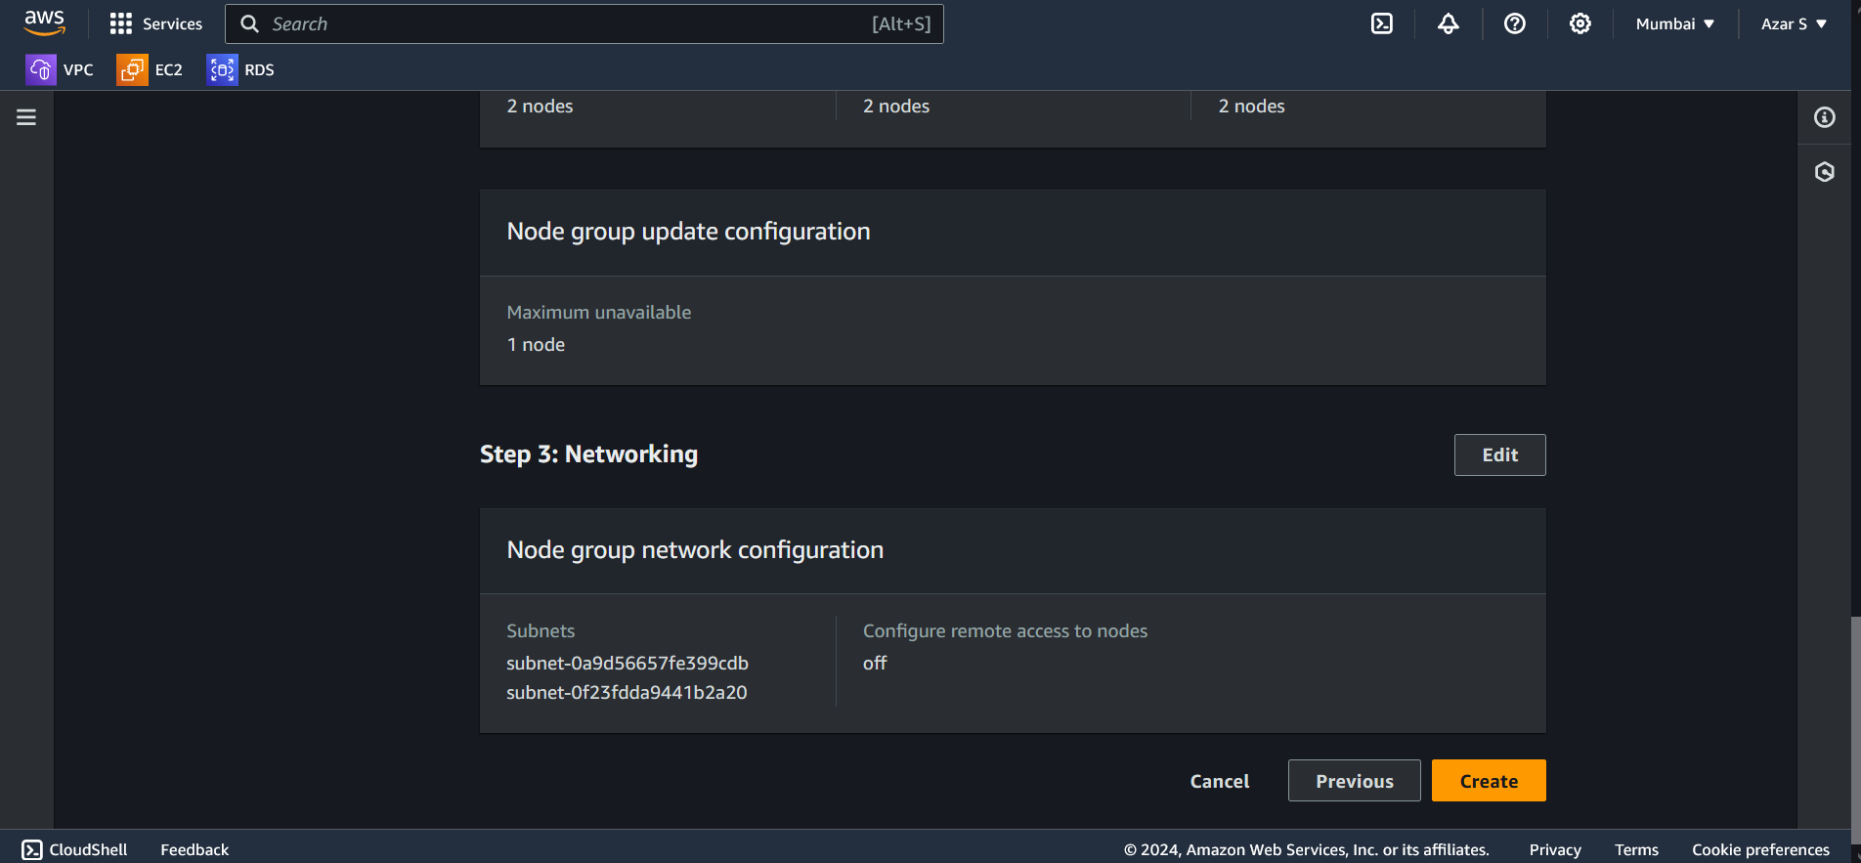 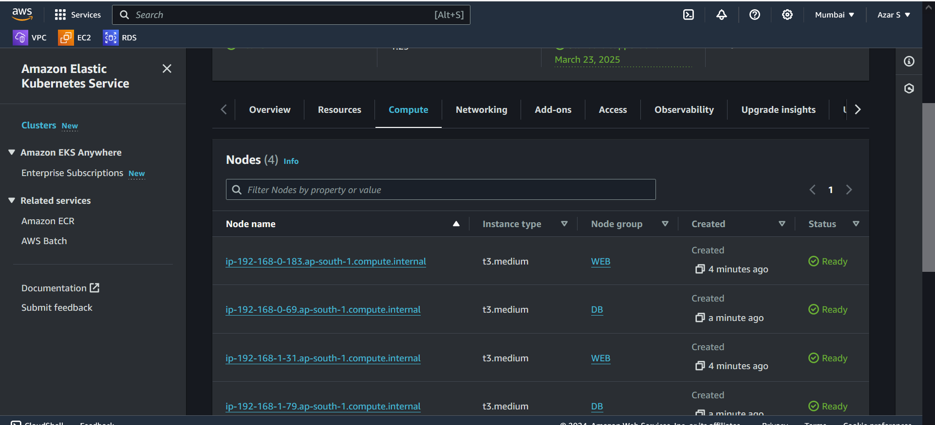 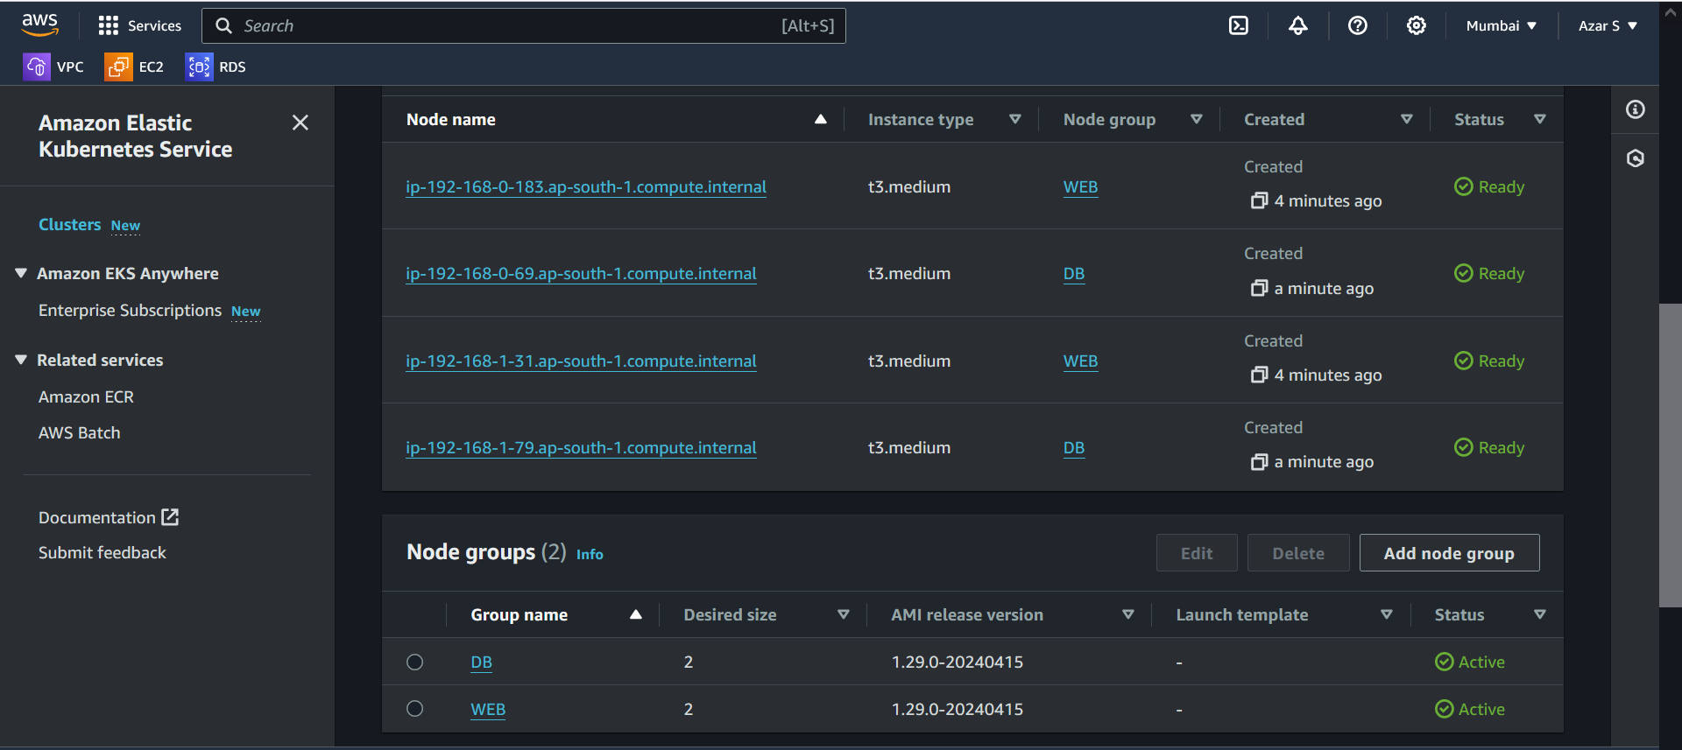 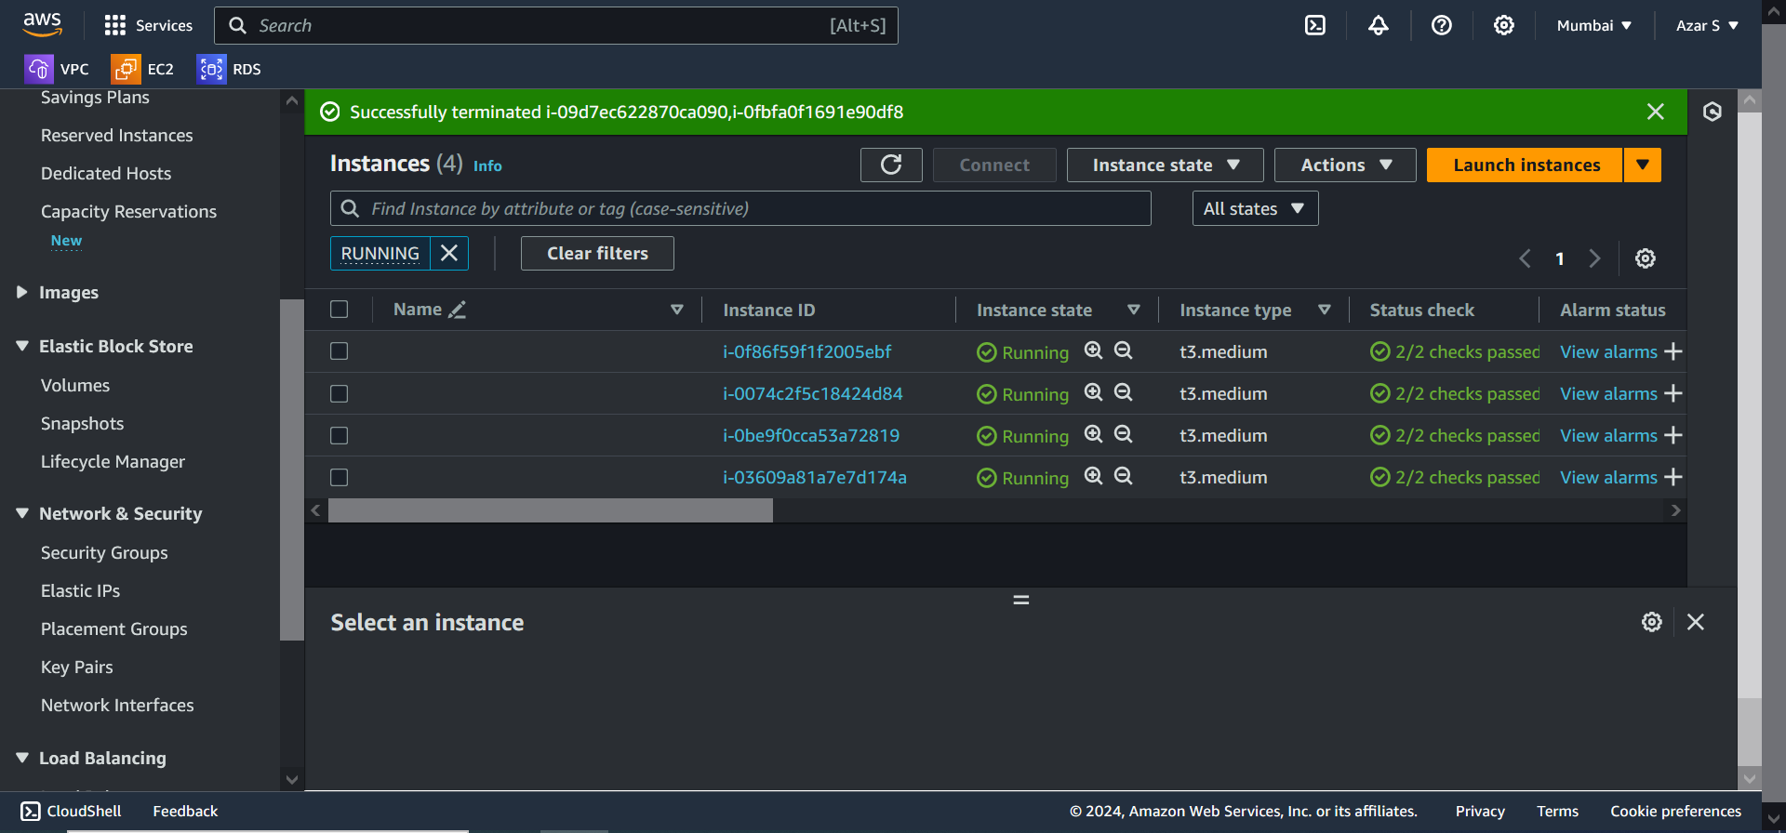

**TO UPDATE THE KUBE CONFIG FILE:**

aws eks update-kubeconfig --region ap-south-1 --name cluster1

**TO SEE THE CLUSTER INFORMATION:**

kubectl cluster-info

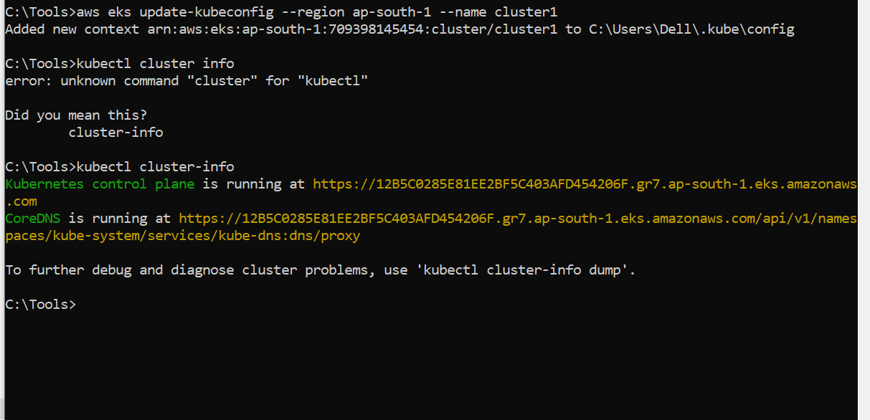

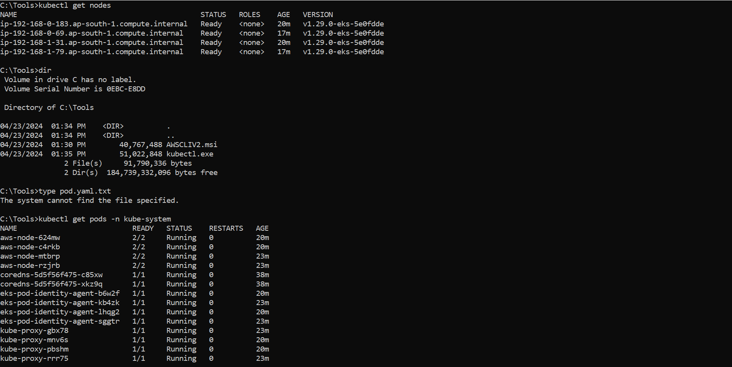 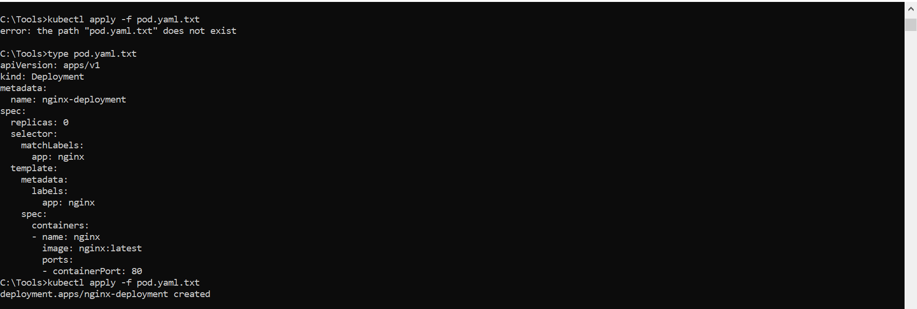 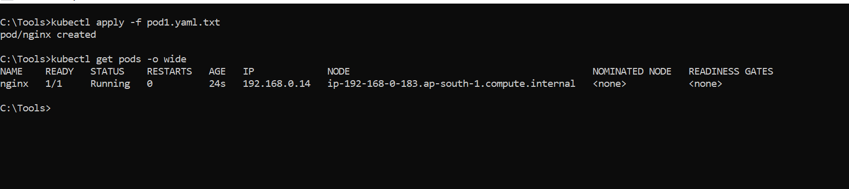 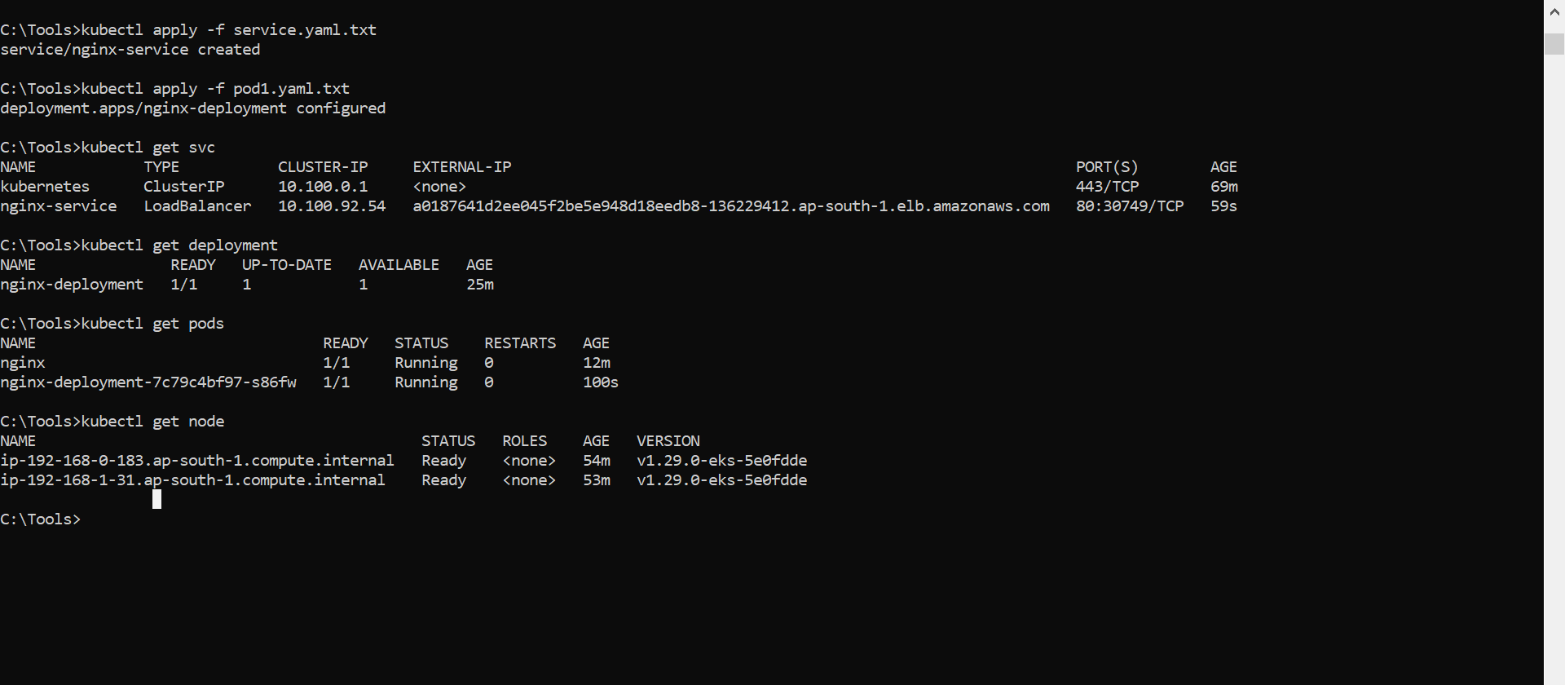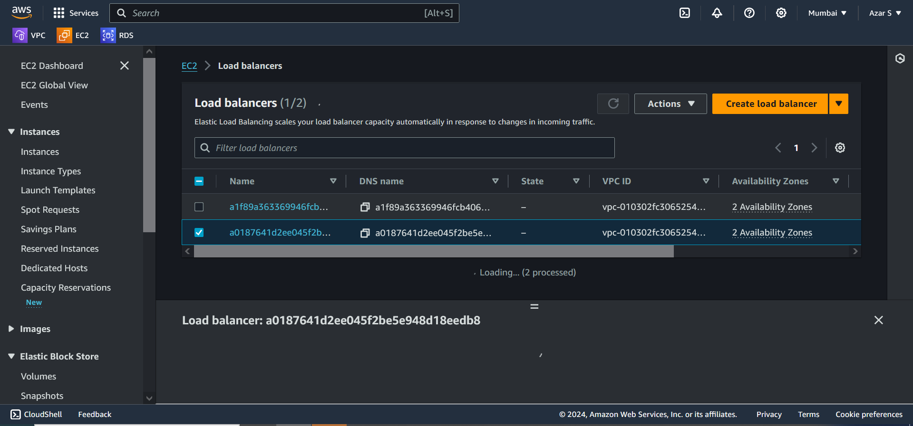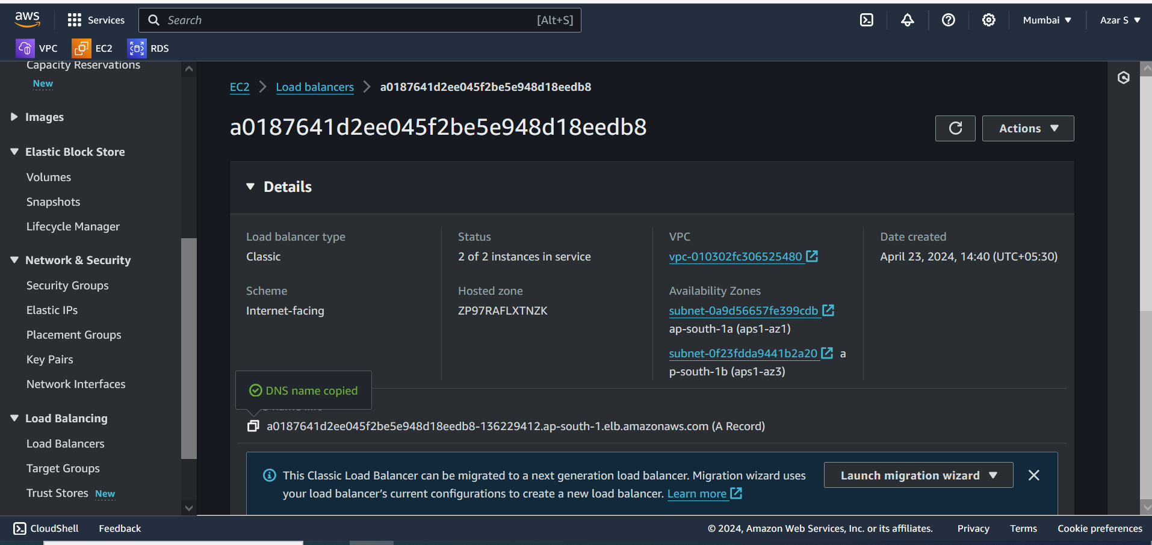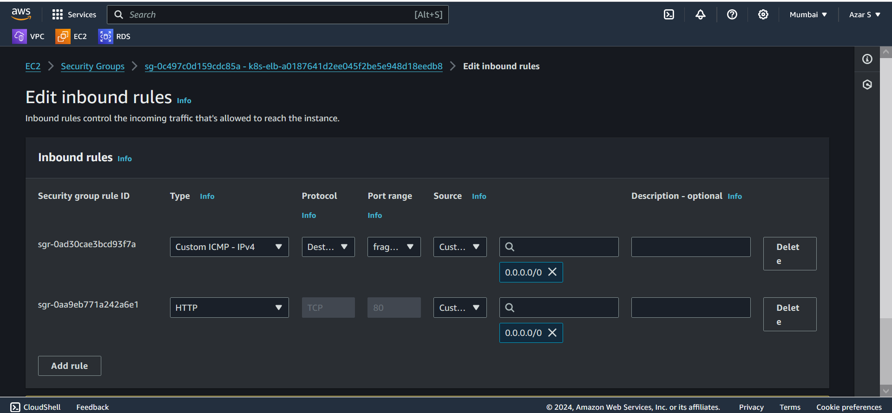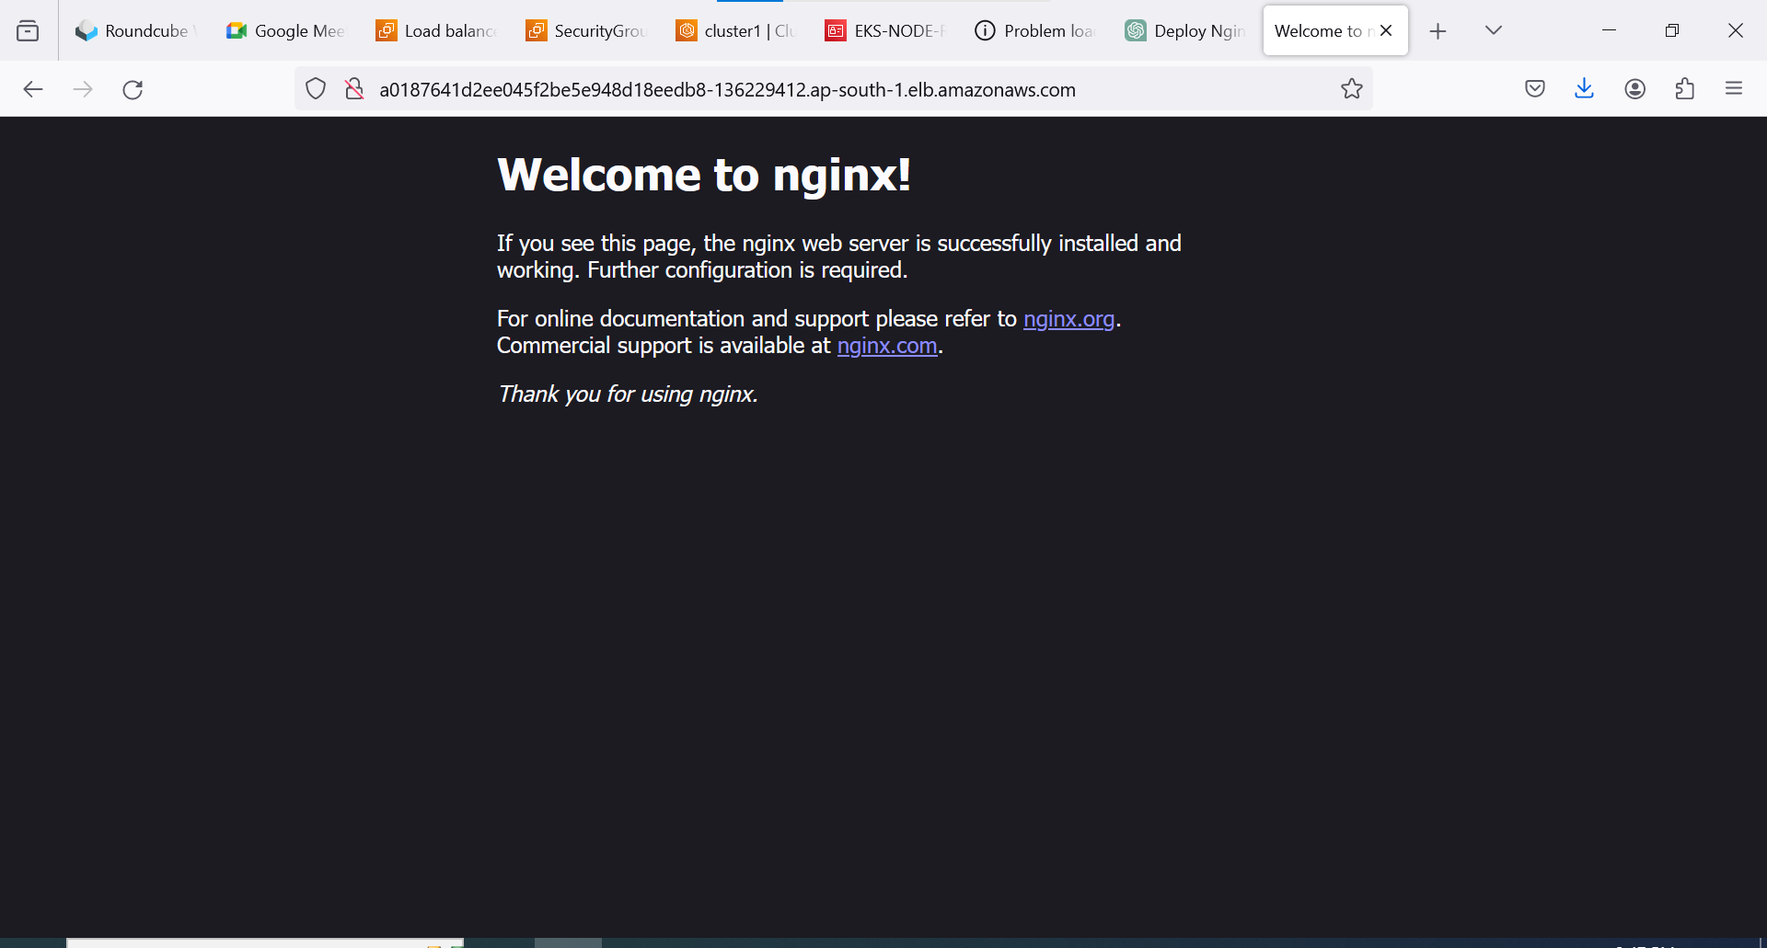

**MANIFEST FILE:**

**Pod.yaml**

apiVersion: apps/v1

kind: Deployment

metadata:

name: nginx-deployment

spec:

replicas: 1

selector:

matchLabels:

app: nginx

template:

metadata:

labels:

app: nginx

spec:

containers:

- name: nginx

image: nginx:latest

ports:

- containerPort: 80

**Service.yaml**

apiVersion: v1

kind: Service

metadata:

name: nginx-service

spec:

selector:

app: nginx

ports:

- protocol: TCP

port: 80

targetPort: 80

type: LoadBalancer

